E - Store Web Application

**ABSTRACT**

Our problem is to automate day to day task of small shops by giving them a digital interface. A shopkeeper has to keep record of his sales, customers, purchases and total calculation at end of the day. This is normally done on paper and by manually calculated. Also, doing it on paper or just manually entering on excel is too much of hassle. Also, data cannot be preserved and there is chance of loss of data.

This is what our true task is to automate the most of the mentioned problems a normal shopkeeper faces and give them a digital helping hand. An application that automates everything for you, so you can relax.

**ACKNOWLEDGEMENT**

We would personally like to Thank and acknowledge all who made this project possible and a success. It is my earnest endeavour to express my sincere thanks to the faculty for their kind co-operation, help and never-ending support.

First, we would take this opportunity and thank our Professor Mrs. Larissa Pegado for her continuous support and encouragement, without which the successful completion of this project would have been impossible.

Without her encouragement, constant guidance, interest and her innovative ideas, we would not finish this project. Without her vast knowledge of programming language and various aspect of software development we would have been unable to accomplish the task of completing this project.

Last but not the least I would like to thank all other teachers of I.T Department who directly and indirectly helped us in the completion of the project.

**DECLARATION**

I hereby declare that the project entitled, “**E-Store Web Application** ” done at **Shri GPM College**, has not been in any case duplicated to submit to any other university for the award of any degree. To the best of my knowledge other than me, no one has submitted to any other university.

The project is done in partial fulfilment of the requirements for the award of degree of **BACHELOR OF SCIENCE (Computer Science)** to be submitted as final semester project as part of our curriculum.

Index

|  |  |
| --- | --- |
|  | Topic |
| Chapter 1 | Introduction |
| Chapter 2 | Technology and Implementation |
| Chapter 3 | Requirements And Analysis |
| Chapter 4 | System Design |
| Chapter 5 | Modules And Backend |
| Chapter 6 | Conclusion And Futures |
| Chapter 7 | BIBLIOGRAPHY |

# TABLE OF CONTENTS

## Chapter 1: Introduction

1.1 Background

1.2 Objective

1.3 Purpose

1.4 Scope

## Chapter 2: Survey of Technology

2.1 Similar System

2.2 Features

2.3 Technology Implementation

2.4 Comparative Analysis

## Chapter 3: Requirement and Analysis

3.1 problem definition

3.2 Requirement Analysis

3.3 Planning and Scheduling

3.3.2 Gantt Chart

3.3.3 Pert Chart

3.3.4 ER diagram

3.3.5 Use case diagram

3.3.6 Activity diagram

3.3.7 data flow diagram

## Chapter 4: System design

4.1 basic modules

4.2 flowchart

## Chapter 5: modules and backend

5.1 Modules and Backend Code

## Chapter 6: conclusion and futures

6.1 Conclusion

6.2 Project Futures Option

## Chapter 7: bibliography

7.1 Credits and Reference

Chapter 1: Introduction

# BACKGROUND:

The project title is 'e-Store Manager' which is a GUI based desktop application purely made in python. This app will be having a login screen and full functionality to make invoice bills for the customers by the shopkeeper of big and small shops and stores! This application provides a Interface between the user and back-end which will make invoice bills in the form of a pdf and Then it will print (store in drive) pdf invoice immediately while storing the customers personal data in separate database and the list of the items he bought in another database! Which can be used for later needs by the shopkeeper for the analysis of the items sold or to look and download the invoice bill for the customer later!

# OBJECTIVES:

* To Reduce the hassle of transactions for small to medium stores.
* To generate smart invoices in PDF format and reduce paperwork.
* To keep track of all previous transactions of each product linked to each customer in databases.
* To create proper analysis and visualization of total sales and top sales for each product type.
* To make admin (employer / owner) easy to access all the information at one place.
* To make a simple user-friendly UI / UX to access desktop / web application.
* To provide a digital platform for every small shop owner to go full digital.

# OUR PURPOSE:

The aim of the project is to make a interface between user (employees of the shop or mini-market) to fetch bills, invoices and also access record of previously made bills! In summary, to automate most common practices of small to medium shops and digitalize them to help them grow and scale their businesses! Which will reduce paperwork and bring transparency to the business.

# SCOPE:

## STAKEHOLDERS:

Adarsh Sunil Singh

## FEATURES:

* The application also helps the shopkeeper/owner to generate invoices in form of pdf or image.
* The pdf will also contain scannable QR code which will also contain information and useful links!
* The bill for each user and user information will be added to existing database.
* Using previous record of customer, shop owner can just search his details by name or phone number to make a new purchase faster without filling each data again.
* The database can be used to re-create bill invoices for previous customers or can be accessed to do data analysis for the employer or owner of the shop to know the bills.
* There will be several databases for the employees and the users! This will also help the shop owner or business owner to set track of the customers and use info to contact each customer for offers, discounts and to reduce hassle of registering new user!

## WORKING OF SYSTEM:

* The E-Store Manager Application is Business Side application that provides Small to Medium Size Businesses or Stores a clean, transparent and digital environment.
* This will be a web application which will be installed on your system. So, user can just login using front-end side by just typing valid URL for example -> <http://127.0.0.1:8000/admin> is to login to admin page.
* Based on the designation of one’s employees several users can be created with different permissions. Example, A person with admin privilege can be assigned to see all purchases made by customers, login and exit time of his employees, maximum sales, etc. A person with sub-manager and Employee can make purchases for customers and use our system to do bill and Produce Invoice.
* Our System records history of all user logins and exits, it creates a database for the list of products, all purchase records made by the customers in real-time.
* Despite Our Complex Process, one can easily navigate through all the functionalities and different features. Thanks, to our simple User-Friendly UI.
* Navigating to Different Functions is just like scrolling a web page and doing shopping on amazon / flipkart. User can just click and view all current operation and make purchase for customer by just a click. Everything is automated already.

## EXCLUSIONS:

* Some of the features like Big-Data and advance Database management things are excluded due to the scope of the project is to target small to medium size shops rather than tech giants like DMart and Big Bazaar.
* We haven’t yet included the barcode scan feature to scan and make payments based on barcode, this can be added in future.
* We don’t support UPI payment gateway to confirm purchases automatically.
* We don’t support online transactions since this is targeted for manual transactions.
* We haven’t added custom domain name to use our app, since it’s desktop application which uses bit of web font-end.

## LIMITATIONS:

* Our Application is based on Django Framework and have python, So it may not outperform the other platforms which are made with Java or node/ExpressJS.
* Our Application doesn’t have support for UPI, So user has to manually confirm each purchase.
* Due to lack of barcode scan system, user has to manually enter each entry of the product that customer wants to purchase.
* Ignorance from user on system operation may create complicated issues while purchase record, So user has to be aware.
* Since, our purchases are made manually it creates lack of transparency for some shops with bigger number of employees.
* Applications can’t be run on older systems, It needs Windows 10 or Linux.
* Due to manual work, It may create process of confirming large orders with different products slower!

## Summary:

Most of the above problems can be avoided by using a barcode scanner and Integration of purchase gateway. But Due to our scope of being made for small businesses, some cannot afford high end scanner and human resource needed to operate those. So, our application still serves the best for the targeted users.

## APPLICABILITY:

* This application is most applicable in small shops and markets to manage large amount of customer purchases.
* This is most suitable application to keep record of every purchase in excel or csv format to keep tract of sales.
* Our application stores information of person who makes the purchase and also the record of his purchase without typing it again in a excel sheet or noting it down.
* Using previous record of customer, shop owner can just search his details by name or phone number to make a new purchase faster without filling each data again. This is much suitable for restaurants and local retain shops.
* The admin part of the application is more useful to shop owner or manager to check on his employee’s login details and sales, as per sales of individual product.
* The friendly UI of the application like a game makes the young generation and the older generation more comfortable with the use of the app.

## ACHIEVEMENTS:

* We learned Intermediate level python programming and gained experience in OOPs concept, Project Design and Implementation.
* We learned HTML5 and CSS3 Basics to create templates for each page of our WEB/Desktop Application.
* We managed to learn SQL and implement our previously learned Database Management Skills.
* We learned Linux CLI (bash) and Ubuntu.
* To manage the version control and keep track of our projects development we learned GIT and GiTea (lighter version of GitHub).
* We learned how to produce Invoices with python and move them with system flow.
* We further learned Django basics and still learning it’s more advance features to make our project better with each patch.

Chapter 2: Survey of technology

# SIMILAR SYSTEMS:

## DUKAAN APP:

This is an Indian application with various features like UPI support, Auto-Pay, barcode scanning integration, All time tech support and more. Dukaan is the easiest way to start, run and grow your online business. They provide ready to deploy apps as well as custom application with add-ons plugins.

There features are as follows ->

* Design tools
* Restaurant Dining
* Unique Themes
* Online Payments
* Custom Domain
* Easy Pages
* Customer List
* And so on ...

You can learn more about them by visiting <https://mydukaan.io/>

## DIGITAL RETAIL APPS:

This is another international giant which has a big market share for e-commerce applications for medium size businesses. Their solutions have features like Self-Pay, Auto-Pay, Data Base support, etc. which makes them prime candite to be on the list. The only con is the pricing which is too high for small size businesses in India and It’s not a Make In India project.

# **After a career advising several of the global Fortune 100 tech companies, Wendy MacKinnon founded Digital Retail Apps and conceptualized SelfPay as an in-store shopping assistant to better meet the needs of mobile shoppers.**

There feature like **SelfPay** gives shoppers a way to skip the checkout line and retailers a simple way to validate digital receipts on exit, assisting with loss prevention and a staff audit trail.

# FEATURES:

* The application also helps the shopkeeper/owner to generate invoices in form of pdf or image.
* The pdf will also contain scannable QR code which will also contain information and useful links!
* The bill for each user and user information will be added to existing database.
* Using previous record of customer, shop owner can just search his details by name or phone number to make a new purchase faster without filling each data again.
* The database can be used to re-create bill invoices for previous customers or can be accessed to do data analysis for the employer or owner of the shop to know the bills.
* There will be several databases for the employees and the users! This will also help the shop owner or business owner to set track of the customers and use info to contact each customer for offers, discounts and to reduce hassle of registering new user!

# TECHNOLOGY IMPLEMENTATION:

## SECURITY:

Our application has Its database encrypted so we have a quite secure environment to store some sensitive information without a worry. We use Django Framework which has In-built security implementations and various features for Authentication. We use the latest patches and most advance python version v3.10.0 for our project. Still, it’s on user to trust it’s employee to put in-charge of this app.

On database side, we use SQL and the data is backup up every day or certain period of time. To prevent any major data loss. We use the .csv format to store the most of the data as it’s more convenient and less memory consuming on both sides. The application can run without using internet which allows it immunity to most of the network hacks but it’s still can be hacked using internal network via router or external precipitator.

## FUNCTIONALITIES:

Our most of the functionalities are focused on employee side, to make purchases, register new customer, add discount and other major features included. This is to make the real work of the employee the easier. The time consumed to keep record of everything or calculate today’s sum is always a headache for a normal shopkeeper now we can automate that task while making the purchase. So, with our automated back-end logic each time we make new purchase the info of the user is added to the database. So, we can get the option to autofill data of the user to make the overall process faster. The calculation of each product is done on the go, user just has to enter product code and all the details will be added. The send Invoice option can be used to send the BILL/Invoice to the customer by the user as a pdf attachment with some offers and coupon codes in the email.

The admin side however can do all the task of the employees but also view all the record as well as the sensitive information for the customers like phone numbers, emails, etc. He can pull any data he needs in one go as well as visualize a graph of sales if needed. He can add or remove the user or modify its permissions too.

# Comparative Analysis:

## Analysis:

|  |  |
| --- | --- |
| Target Platforms | All Platforms (Windows and Linux) |
| Speed and Development cost | Low |
| Maintenance Cost | Very Low |
| Long-term Viability | Very High |
| Maturity Level | High |
| Offline Use | Yes |
| Online Transaction Support | No |
| Barcode Scanner Support | No |
| Code Reusability | Total |
| Distribution | Installed and setup done by engineer |
| Access | Accessed via web browser |
| Potential Users | Unlimited |

## Drawback and Limitations:

* Our application is based on Django Framework and have python, so it may not outperform the other platforms which are made with Java or node/ExpressJS.
* Our application doesn’t have support for UPI, so user has to manually confirm each purchase, which may slow down the overall process.
* Due to lack of barcode scan system, user has to manually enter each entry of the product that customer wants to purchase.
* Applications can’t be run on older systems; it needs Windows 10 or Linux.
* Due to manual work, it may create process of confirming large orders with different products slower!
* Some of the users from older generation may still find it hard enough to adapt, but that’s the rare case.

## Lesson LEARNT / FINAL COMMENT:

We Learned that major drawbacks are due to our lack of gateway for online transactions and support for barcode scanning system for purchases. This can be avoided in future integrations but isn’t our scope of the project too make it available for small business? Small businesses and shops tend not to have barcode scanner and in restaurants and other related shops we don’t be needed that. We can still opt for COD or manually verify the transaction and create a Bill without a worry. Adding such expensive technologies to our simple project takes the cost and maintenance sky high.

The local restaurants who place the order and do take a lot can benefit a lot, in my opinion. They will get their daily work of bookkeeping done by our application on back-end. The lack of the online transaction integration is still needed but we will add it soon. But it will have to be dependent on internet to verify those transactions.

We will update as our research goes on!

CHAPTER 3: REQUIREMENTS AND ANALYSIS

# PROBLEM DEFINITION:

Our problem is to automate day to day task of small shops by giving them a digital interface. A shopkeeper has to keep record of his sales, customers, purchases and total calculation at end of the day. This is normally done on paper and by manually calculated. Also, doing it on paper or just manually entering on excel is too much of hassle. Also, data cannot be preserved and there is chance of loss of data.

This is what our true task is to automate the most of the mentioned problems a normal shopkeeper faces and give them a digital helping hand. An application that automates everything for you, so you can relax.

# REQUIREMENTS SPECIFICATIONS:

* To automate keeping record of all purchases, customers info/contacts, total sales
* To Make sure the UI is user-friendly for non-tech users
* To keep Application and maintenance cost low
* To provide tools to get insights in sales data
* Generate e-Invoices and email automatically
* Backup the data by self to keep data secure and functional
* Adding and Removing new products is easy on UI

# HARDWARE AND SOFTWARE REQUIREMENTS:

|  |  |  |
| --- | --- | --- |
|  | Minimum | Recommended |
| Operative System | Windows 10 (Home / Pro) or Linux (Ubuntu / Alpine / CentOS) | Windows 10 (Home / Pro) or Linux (Ubuntu / Alpine / CentOS) |
| Processor | Intel®, AMD, or ARM processor with 64-bit support | Intel®, AMD, or ARM processor with 64-bit support |
| Memory | 8 GB RAM | 16 GB RAM |
| Graphics | Integrated Graphics | Integrated Graphics or Higher |
| Storage | 12 GB or Higher HARD DISC | 32 GB or Higher SSD |
| Python Interpreter | Python 3.8 or Higher | Python 3.10 |
| Django | 3.2.8 LTS | 3.2.8 LTS |

# PRELIMINARY PRODUCT DESCRIPTION:



### HARDWARE & SOFTWARE REQUIREMENTS:

Operating System: Windows 10 (Home / Pro) or Linux (Ubuntu / Alpine / CentOS)

Processor: Intel®, AMD, or ARM processor with 64-bit support

RAM: 8 GB or More

Graphics: Integrated or Higher

Storage: 12 GB or Higher

Python: 3.8 or Higher

### INSTALLATION:

Please contact our email for Installation and demo of our service.

Phone : 90 1234 1234

Email: swapnil@example.com

E – STORE Manager

### INTRODUCTION

The aim of the project is to make a interface between user (employees of the shop or mini-market) to fetch bills, invoices and also access record of previously made bills! In summary, to automate most common practices of small to medium shops and digitalize them to help them grow and scale their businesses! Which will reduce paperwork and bring transparency to the business.

# PLANNING AND SCHEDULING:

### Our priority is to get following tasks done in order:

* Complete the base functionality using python and gain new skills needed for the project
* After the Testing Design and make list of the tools we are going to use and learn them
* Create the project architecture
* Start Building Application by dividing it into micro services or Micro Applications
* Join them and make them functional
* Testing face of the application
* Re-design or fix the loose corners
* Deploy Application and Test it
* Add patches regularly!

## GRANTT CHART:

|  |  |  |  |  |  |  |  |
| --- | --- | --- | --- | --- | --- | --- | --- |
|  | July | August | September | October | November | December | January |
| Survey |  |  |  |  |  |  |  |
| Background Study |  |  |  |  |  |  |  |
| Planning |  |  |  |  |  |  |  |
| Design |  |  |  |  |  |  |  |
| Documentation |  |  |  |  |  |  |  |
| Coding |  |  |  |  |  |  |  |
| Testing |  |  |  |  |  |  |  |
| Launch |  |  |  |  |  |  |  |

## PERT CHART:

### Overall Project Scheduling

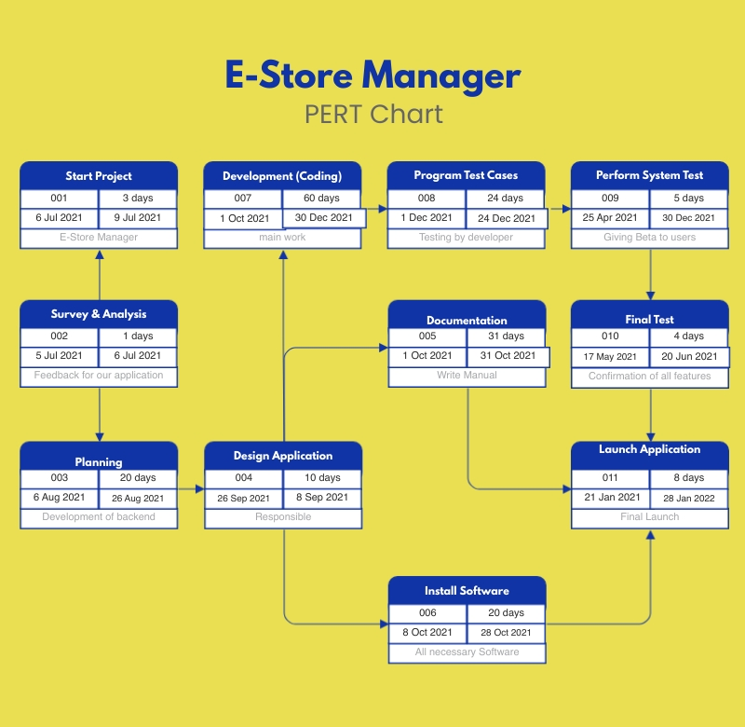

### Coding Part

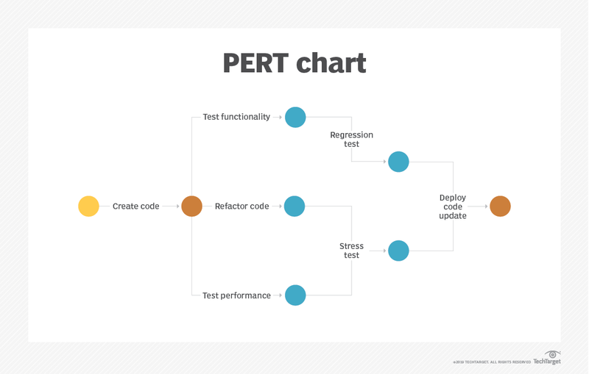

## ER DIAGRAM:

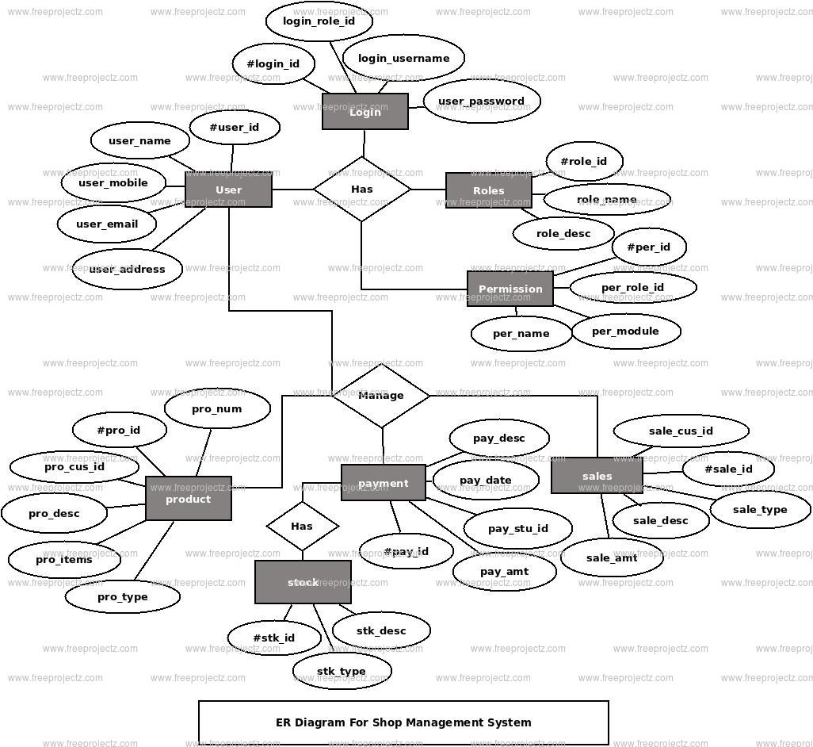

## USE CASE DIAGRAM:

## DATA FLOW DIAGRAM (DFD – Level Zero):

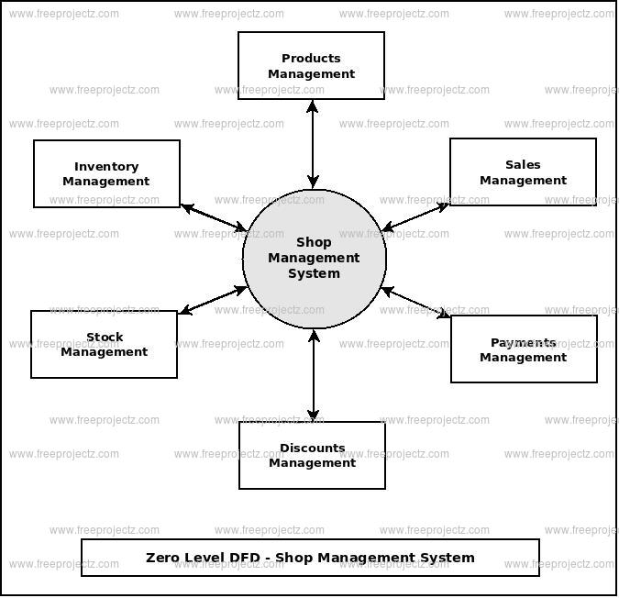

# CONCEPTUAL MODELS:

CHAPTER 4: SYSTEM DESING

# MODULES:

### We are using following CORE PARTS as current development:

* Python (main back-end)
* Django (main back-end)
* Reportlab (pdf generation tool)
* Numpy and Pandas (Data Manipulation and Analysis)
* Sqllite3 (built-in python-django) & MySQL
* Git and Gitea (for version control)

Python: Python is an interpreted high-level general-purpose programming language. Its design philosophy emphasizes code readability with its use of significant indentation. Its language constructs as well as its object-oriented approach aim to help programmers write clear, logical code for small and large-scale projects.

Django: **Django** is a Python-based free and open-source web framework that follows the model–template–views architectural pattern. It is maintained by the Django Software Foundation, an American independent organization established as a 501 non-profit.

Reportlab: It is the most advance PDF development library supported by most of the programming languages. Reportlab can be used to make attractive PDFs and Invoice Documents well. Making is most suitable for our application.

Numpy: NumPy is a library for the Python programming language, adding support for large, multi-dimensional arrays and matrices, along with a large collection of high-level mathematical functions to operate on these arrays.

Pandas: pandas is a software library written for the Python programming language for data manipulation and analysis. In particular, it offers data structures and operations for manipulating numerical tables and time series. It is free software released under the three-clause BSD license. This is used in our application to manage big data and query through it.

SQL: **sqllite3** is the in-built module available in python. It’s a lite version of SQL. **PostgreSQL**, also known as Postgres, is a free and open-source relational database management system emphasizing extensibility and SQL compliance. We used **MySQL**.

Git: Git is a [free and open source](https://git-scm.com/about/free-and-open-source) distributed version control system designed to handle everything from small to very large projects with speed and efficiency.

GiTea: Gitea is a community managed lightweight code hosting solution written in Go. It is published under the MIT license. For more information go to https://gitea.io/en-us/

For Internal Design please check production code for more documentation.

# OVERALL ALGORITHM:

The most of the processes are logical than algorithmic. Most of the algorithms for data encryption and manipulations are handled by Django Framework itself or Pandas Library. The SQL Engine handles the rest of the data storage problems.

Functions:

Start the app > login page > Authenticate > login as employee or admin > choose any feature

Admin > get backup of data (all records) as csv or excel

> pull or query any info

> assign new user or see login details, etc.

User > make a purchase for customer

> generate invoice / bill and send to customer

> register a new customer

## BASIC CONTROL FLOW:

# ADMIN LOGIN Module:

In this module the admin has to login for further shopping

## Algorithm:

**Step 1**- Admin has to first visit the home page and then in admin section he/she has to login

**Step 2**- Admin has to enter his credentials in the given login form

**Step 3**- The credentials will be checked whether the admin is authorized or not

**Step 4**- If the user is not authorized then he will be redirected to the login page

**Step 5**- If the admin is authorized then he/she is successfully logged in into his/her account

## Flow Chart:

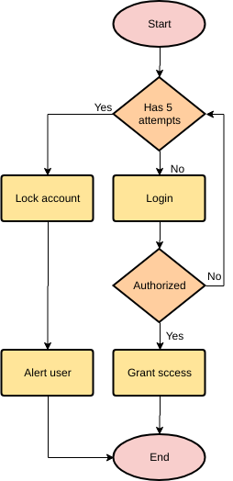

## Interface:

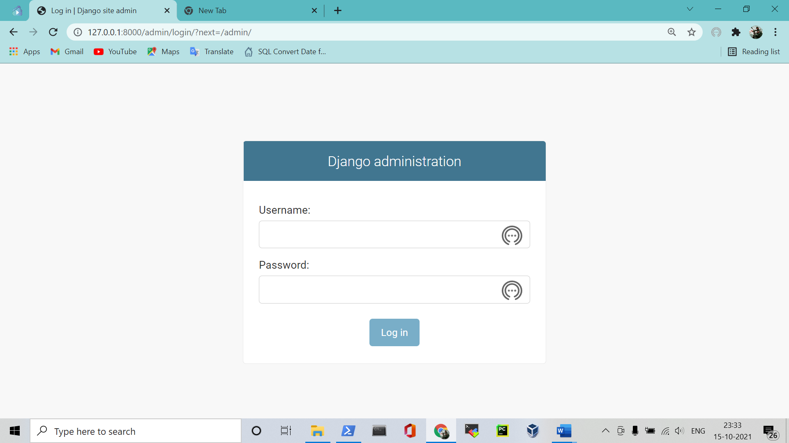

## Validation:

|  |  |
| --- | --- |
| Username | Incorrect username |
| Password | Incorrect password |

# User REGISTRATION MODULE:

In this module admin registration is required

## Algorithm:

**Step 1**- In the home page on the website the admin will first get the “Admin” option

**Step 2-** In admin section the admin will get the registration form in which he/she has to fill his/her credentials

**Step 3-** Once the admin has successfully entered the credentials then their data gets saved in the Database

## Flow Chart:

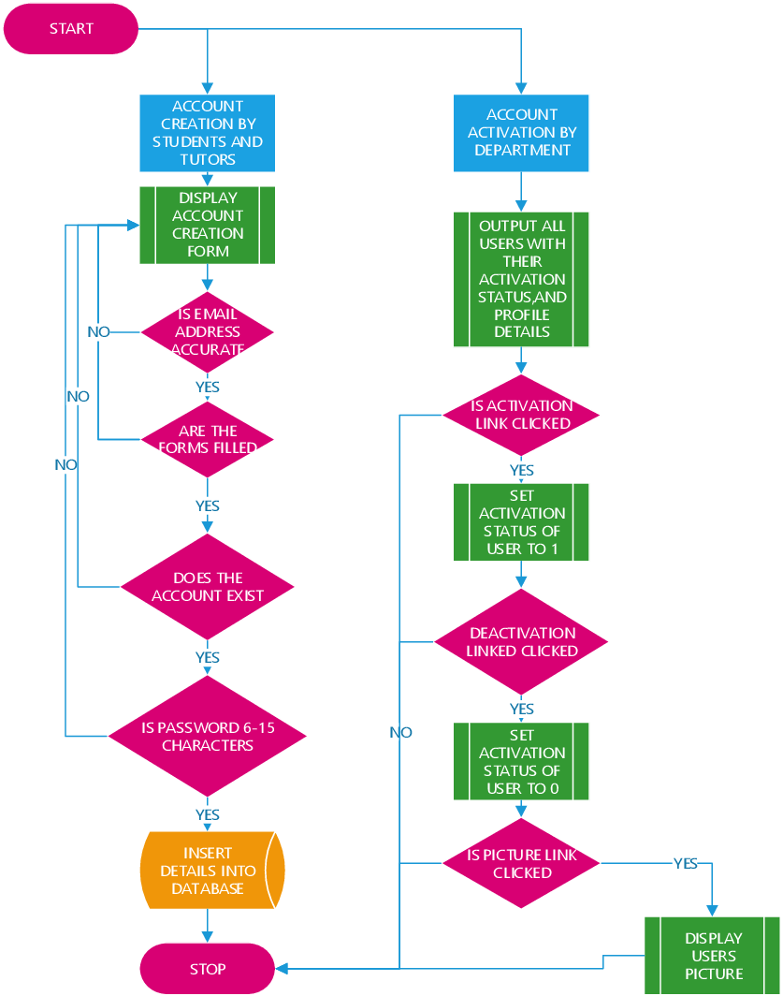

## Interface:

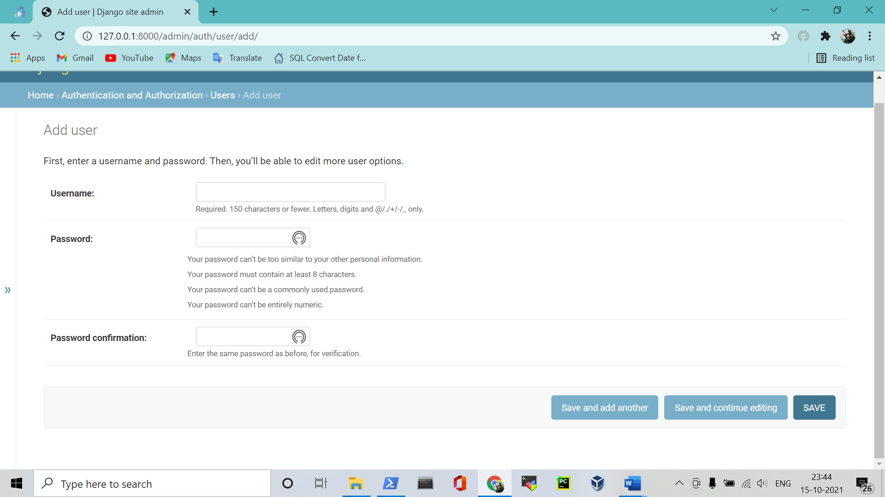

## Validation:

|  |  |
| --- | --- |
| Username | Incorrect username |
| Password | Incorrect password |

# USER REGISTRATION MODULE:

In this module admin registration is required

## Algorithm:

**Step 1**- In the home page on the website the admin will first get the “User” option

**Step 2-** In admin section the admin will get the registration form in which he/she has to fill his/her credentials

**Step 3-** Once the admin has successfully entered the credentials then their data gets saved in the Database

## Flow Chart:



## Interface:



## Validation:

|  |  |
| --- | --- |
| Username | Incorrect username |
| Password | Incorrect password |

# PAYMENT MODULE:

In this module the user has make a payment

## Algorithm

**Step 1-** After adding items to the cart the user needs to go to payment option

**Step 2-** There user is used to make their payment

## Flow Chart:

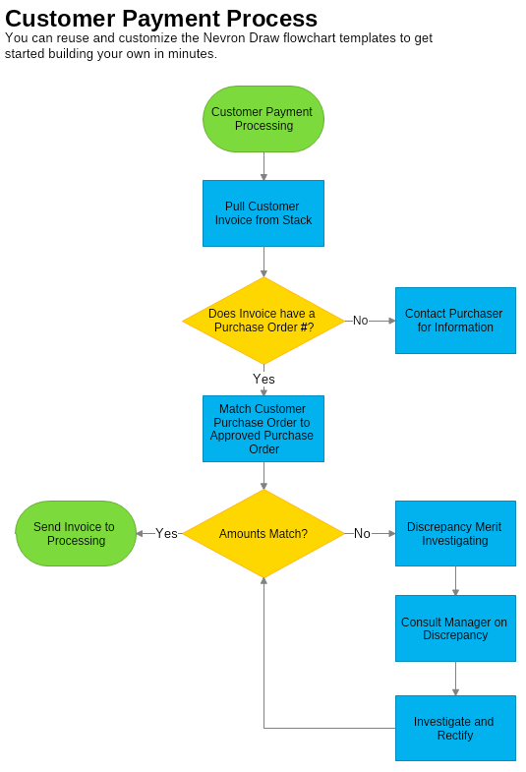

CHAPTER 5: modules and backend

# login module:

## screenshots:

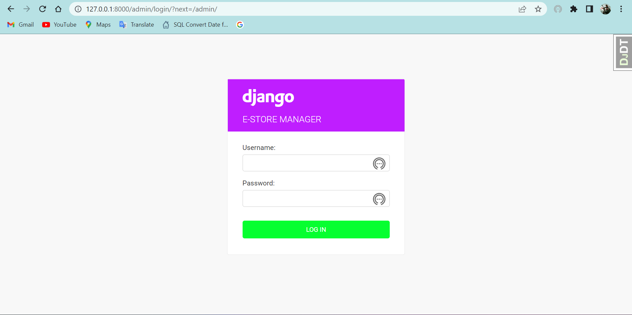

## DATABASE SCHEMA:

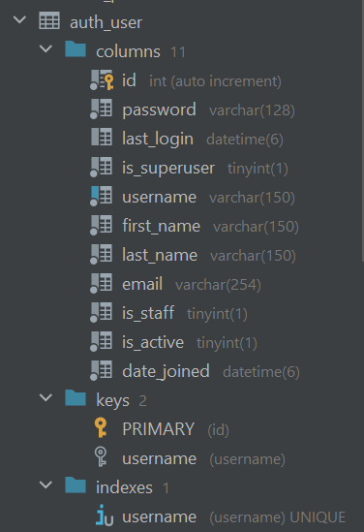

## HTML CODE:

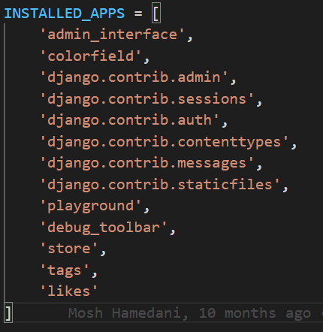



In Above Code, Django.contrib.auth module is where our login and authenticating service is installed.

## POWESHELL RUN PROJECT:

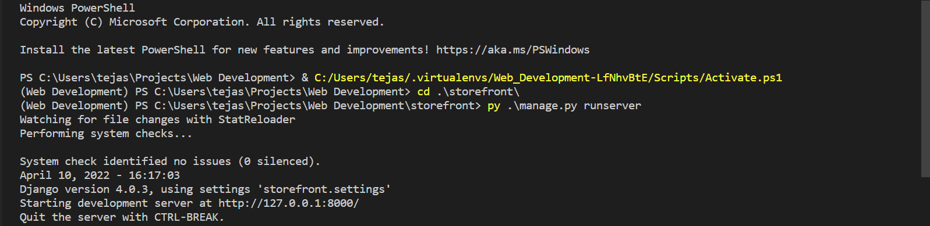

# Home Page:

## Screenshot:

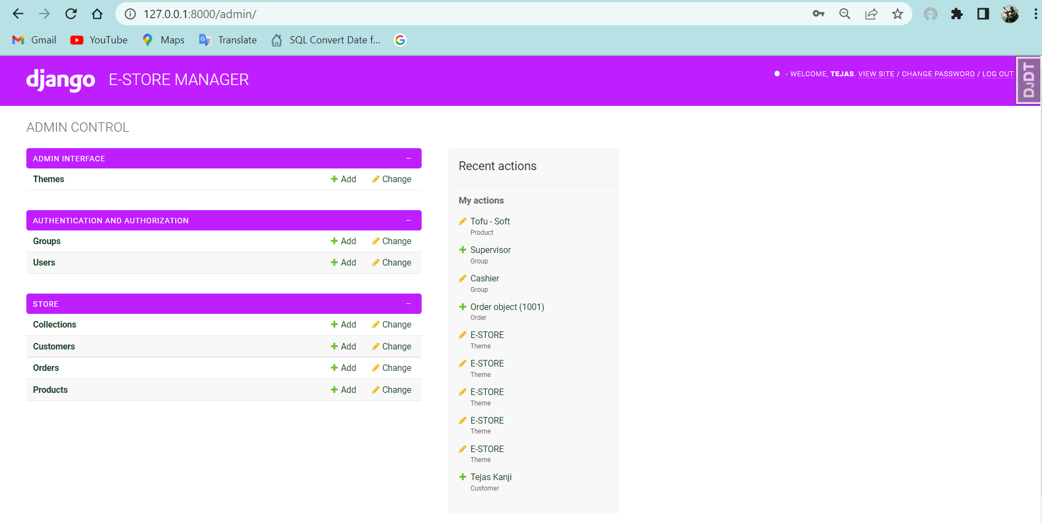

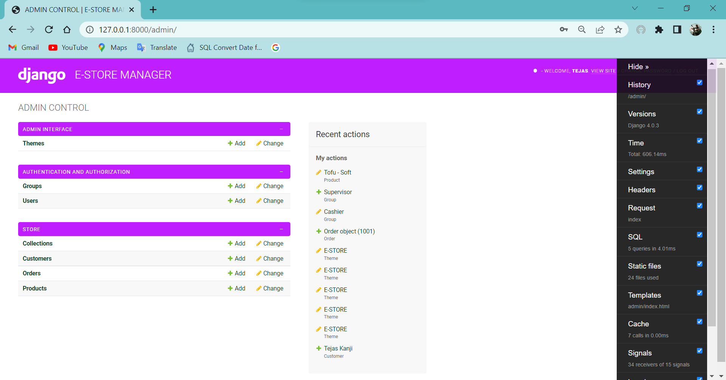

## Backend Code:

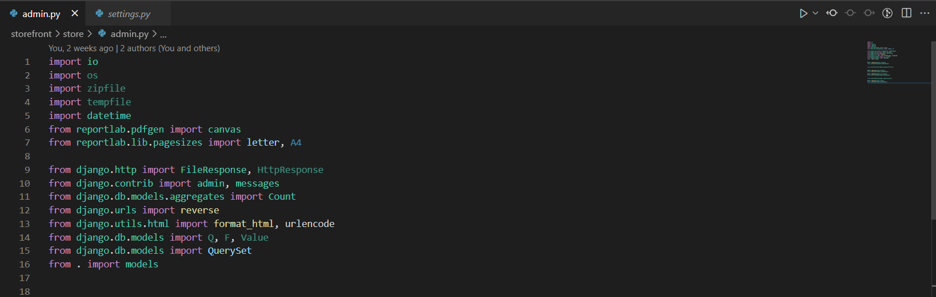

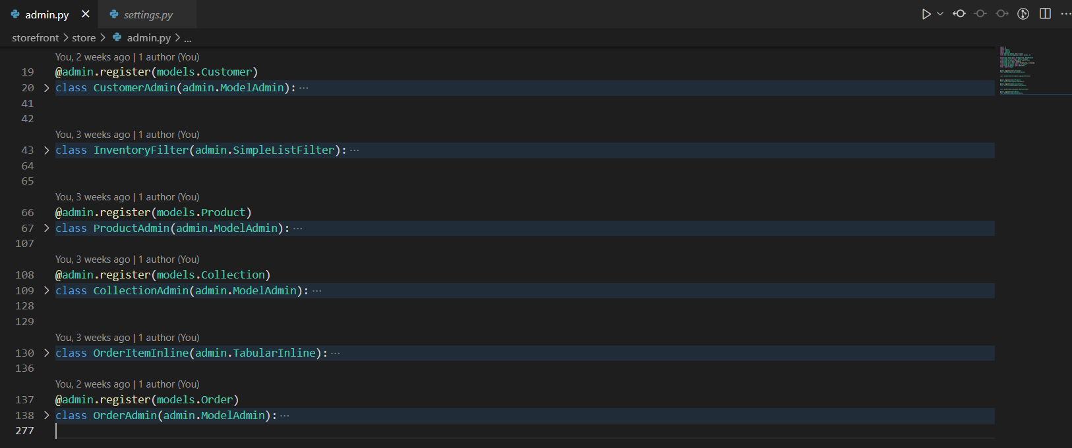

# THEME CENTER:

## Screenshot:

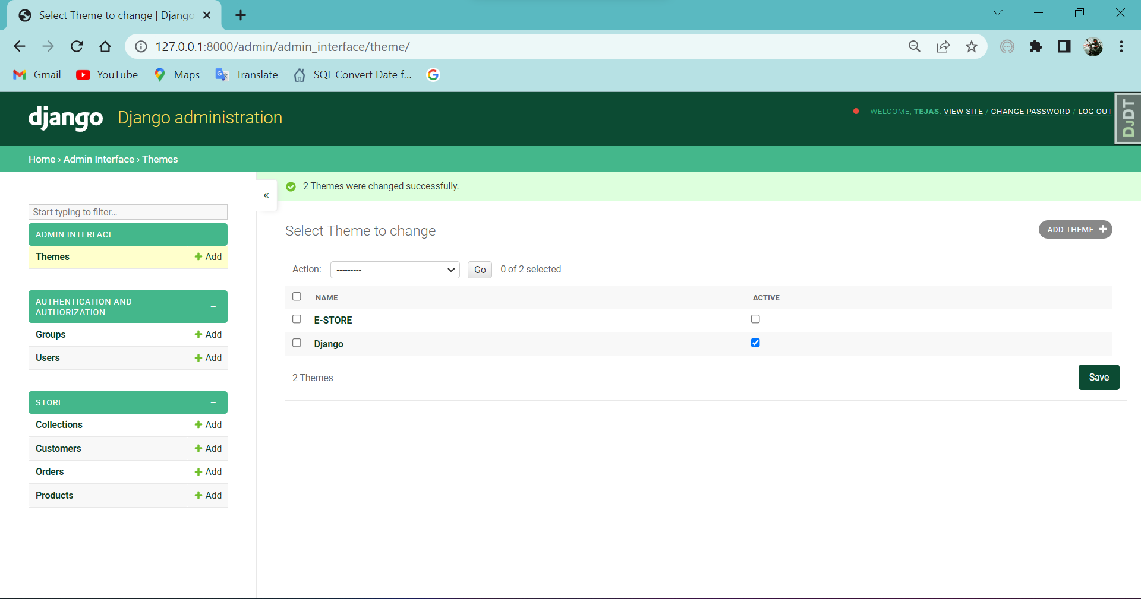

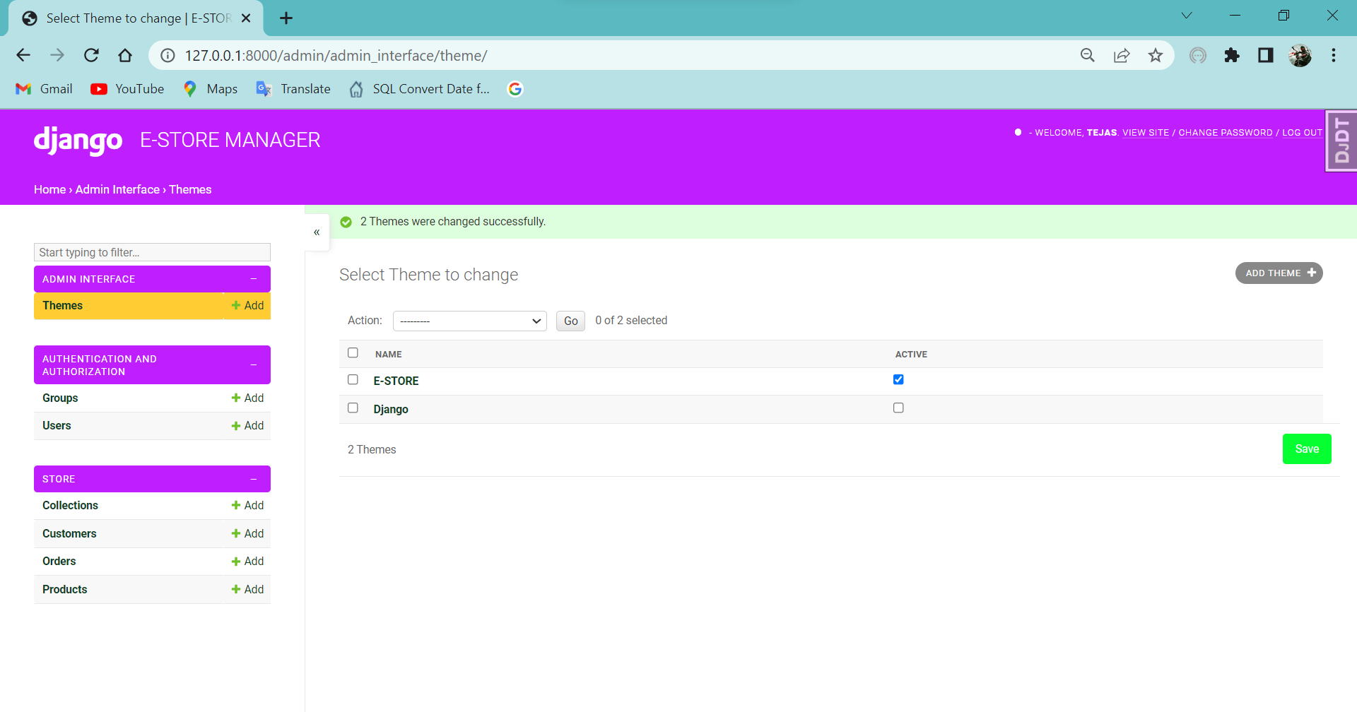

## BACKEND CODE:

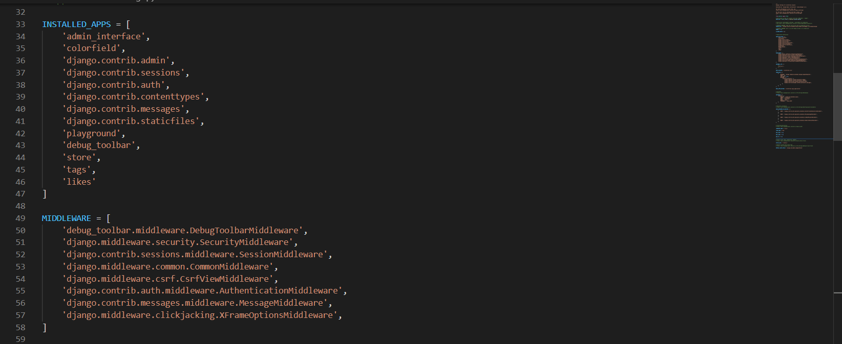

# AUTHENTICATION AND AUTHORIZATION:

## SCREENSHOTS:

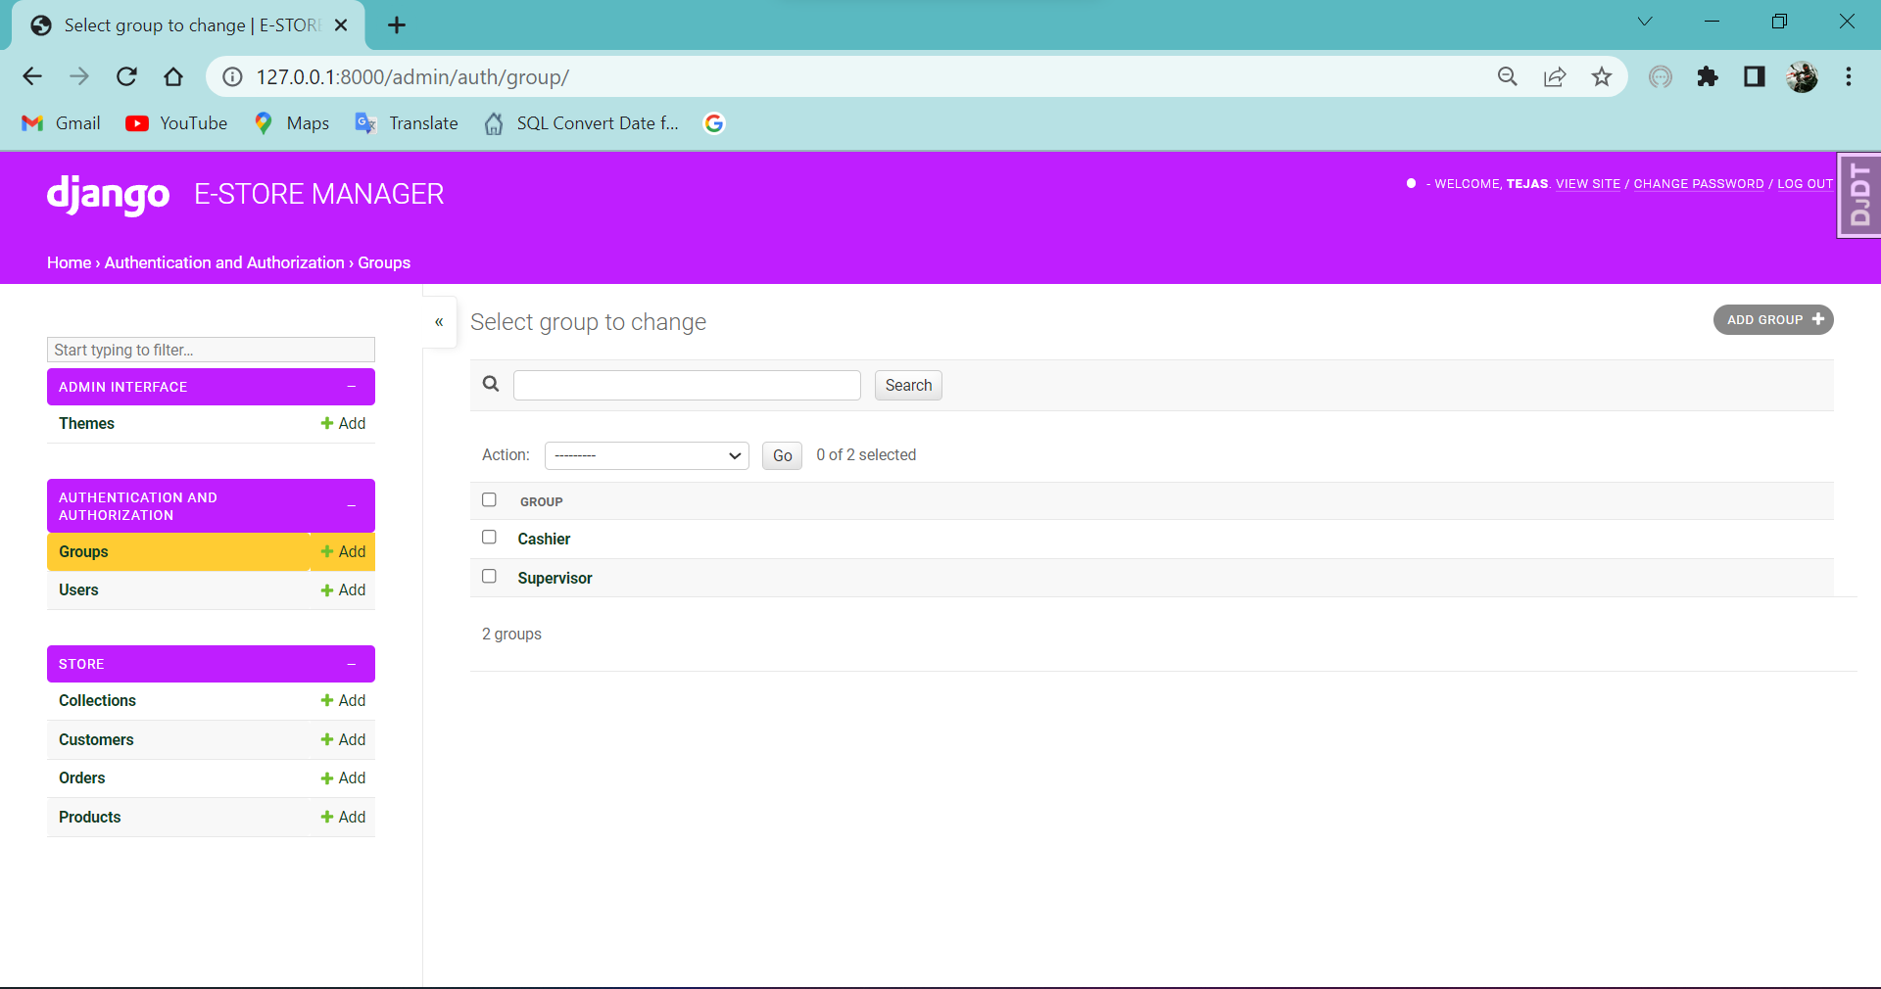

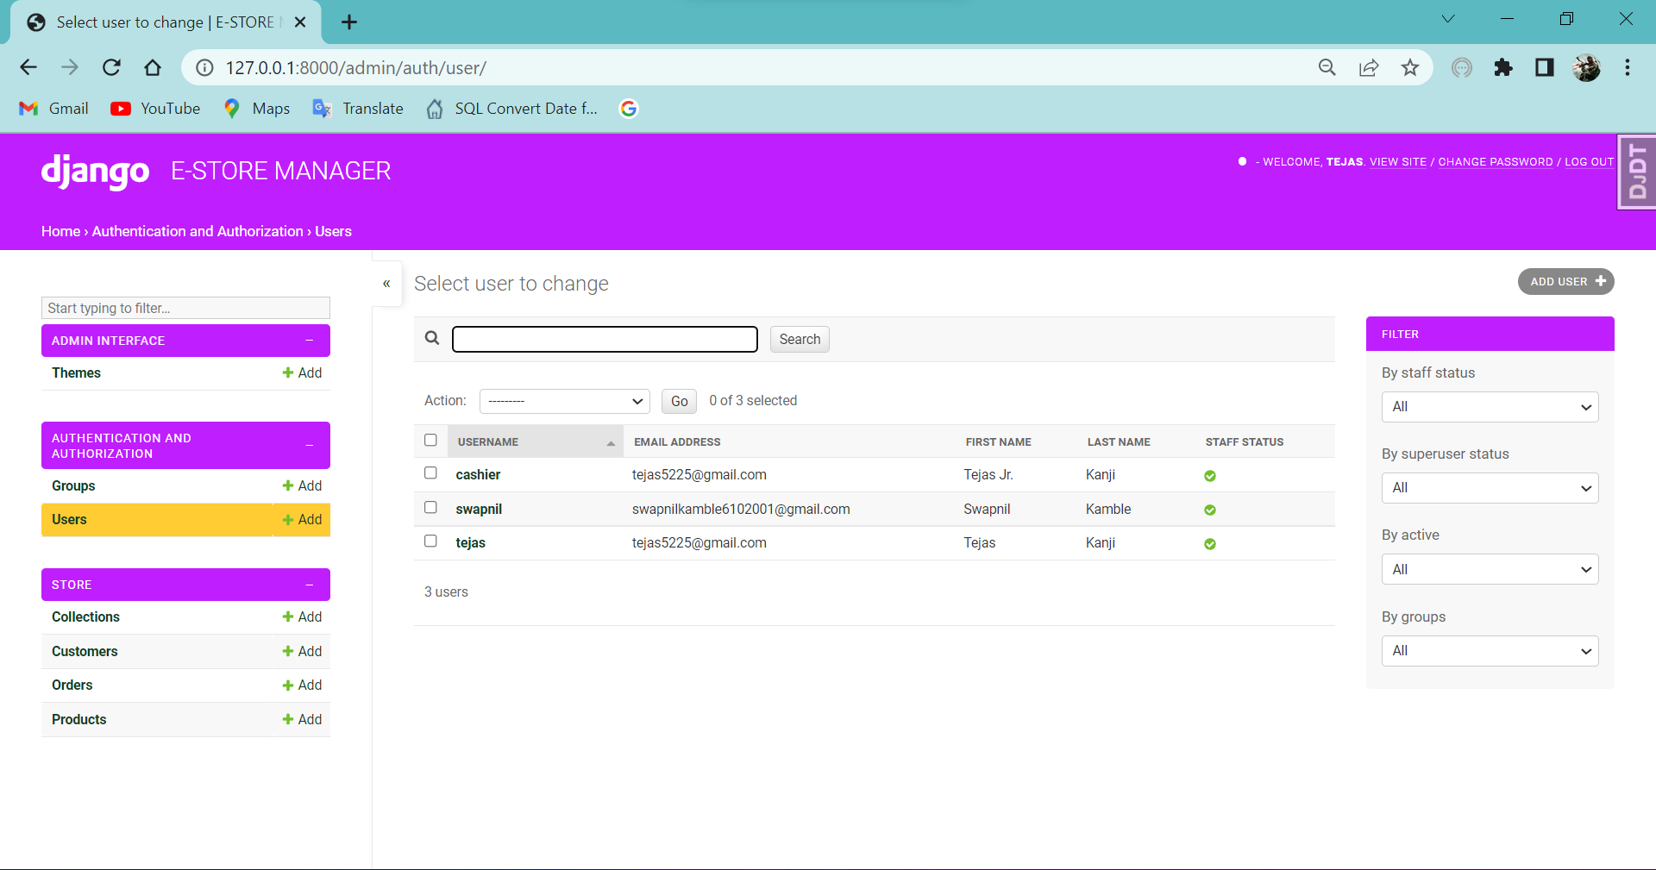

## DATABASE SCHEMAS:

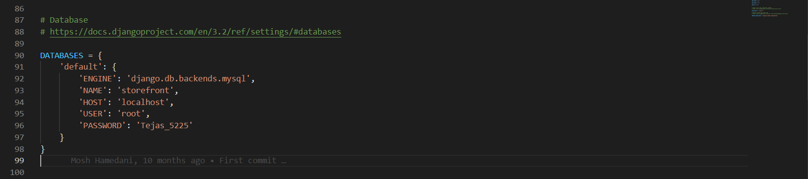

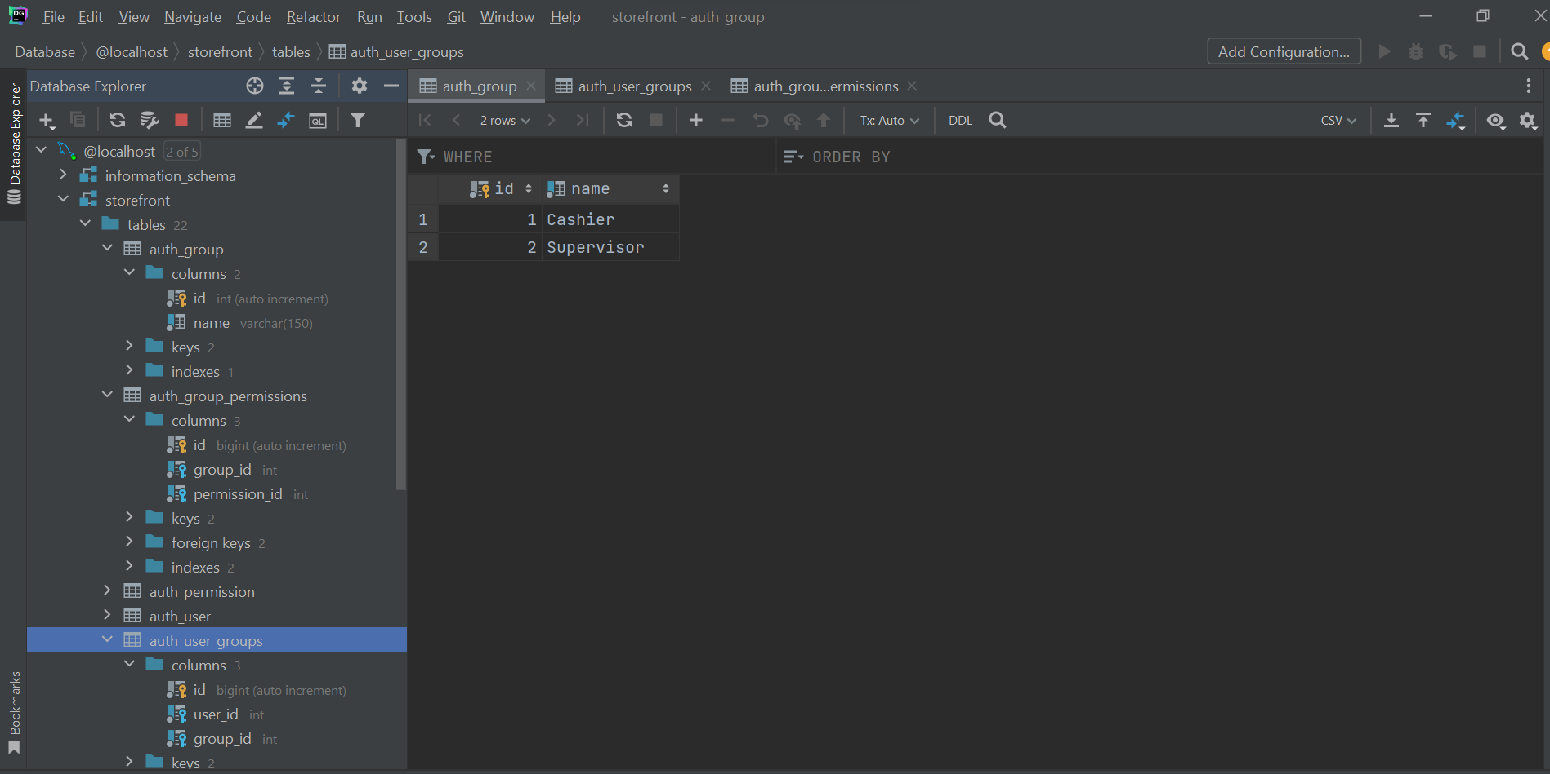

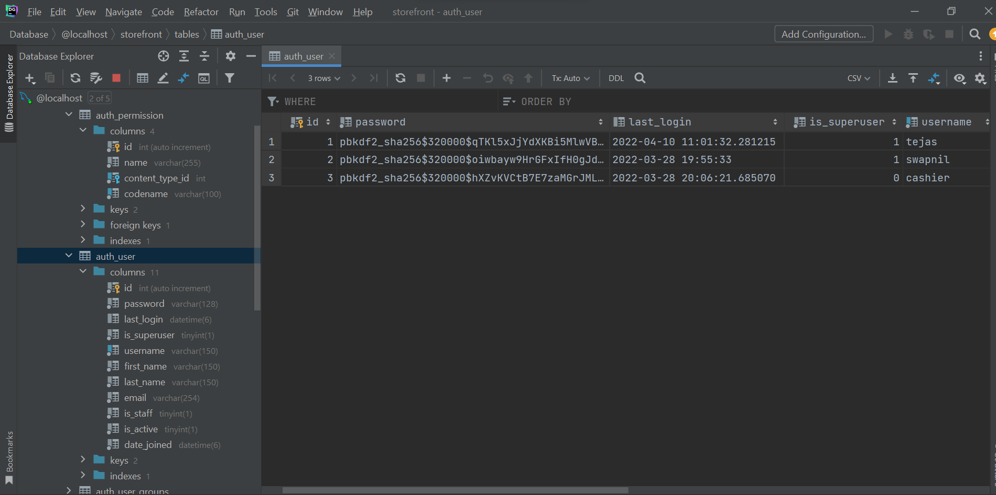

# COLLECTIONS MODULE:

## SCREENSHOTS:

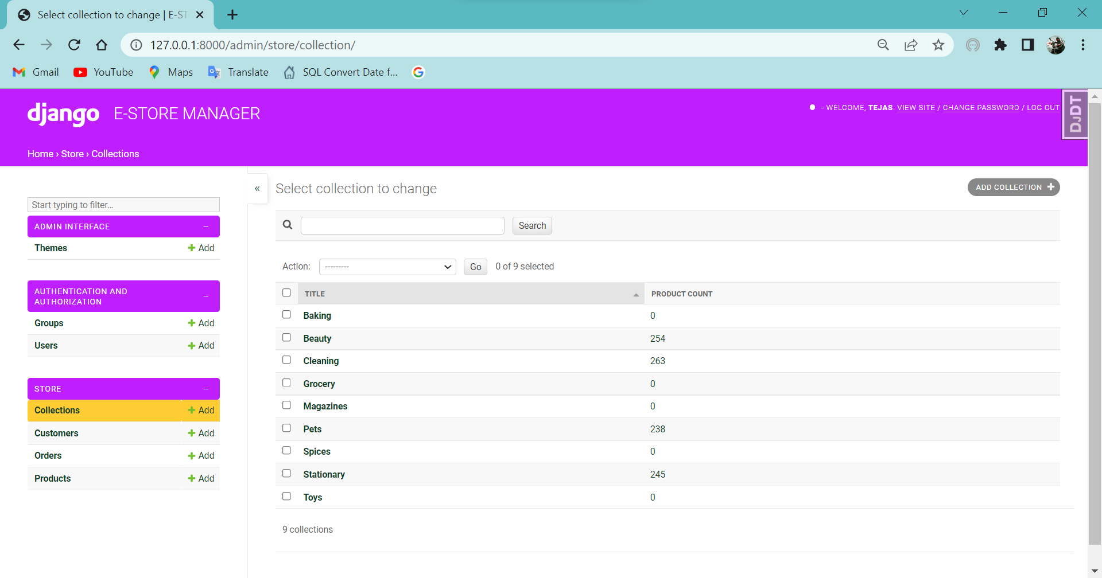

## DATABASE CODE:

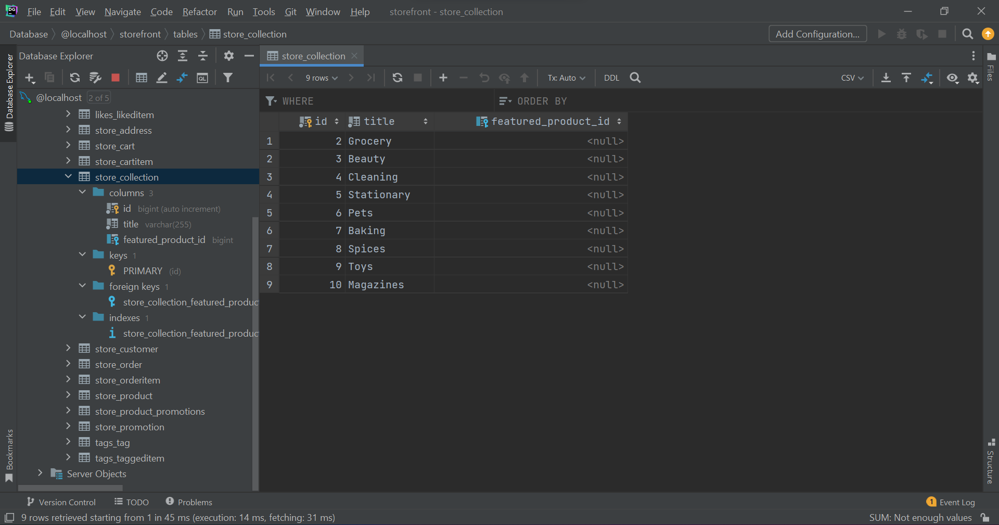

## BACKEND CODE:

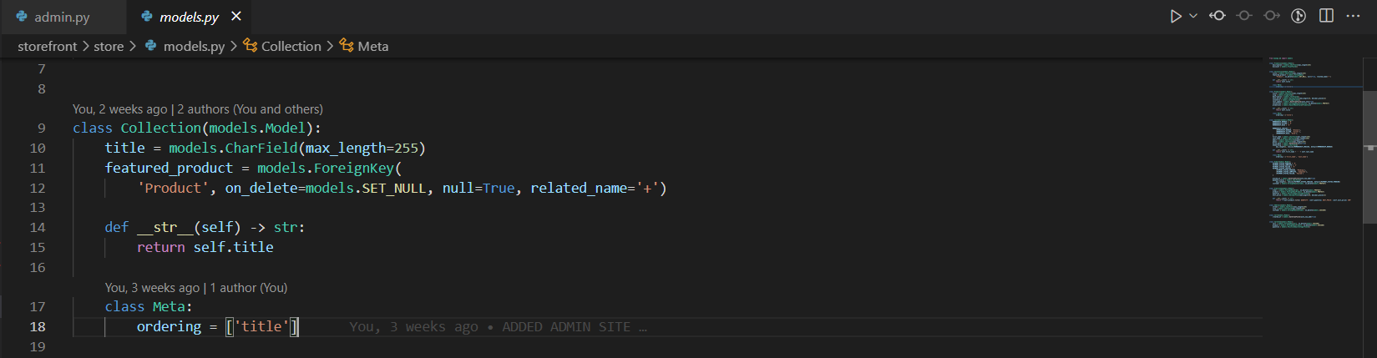

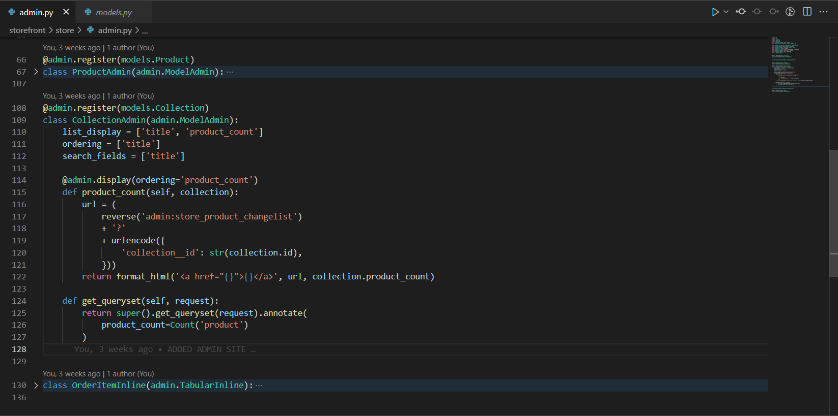

# Custoemrs MODULE:

## SCREENSHOTS:

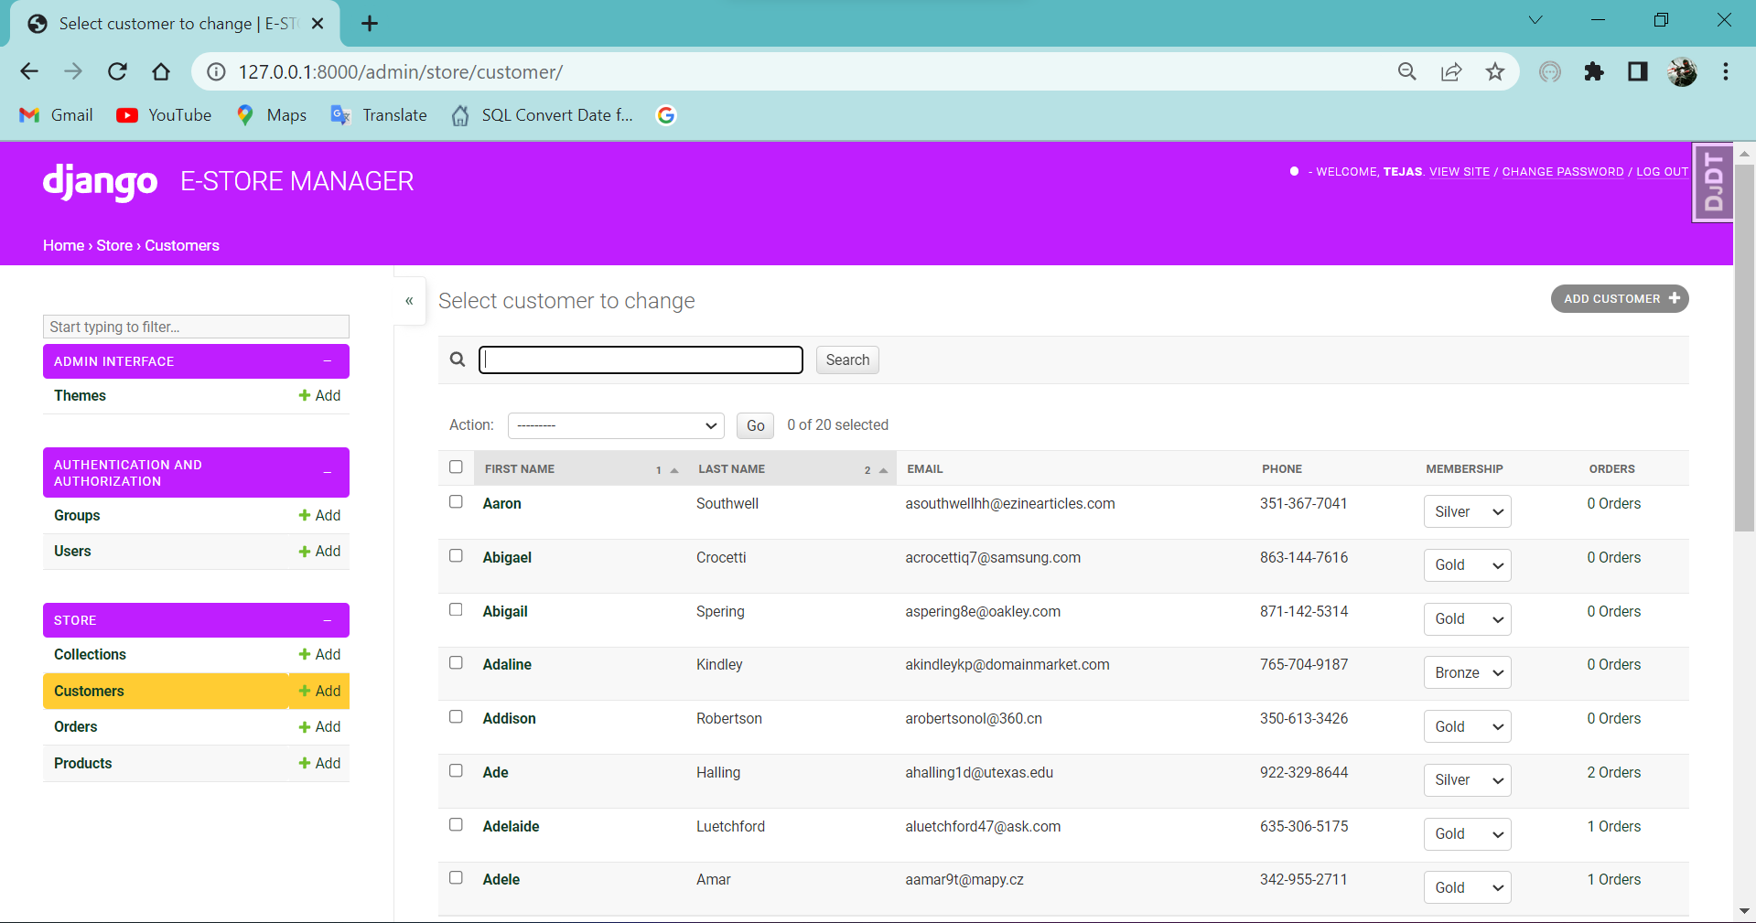

## DATABASE SCHEMAS:

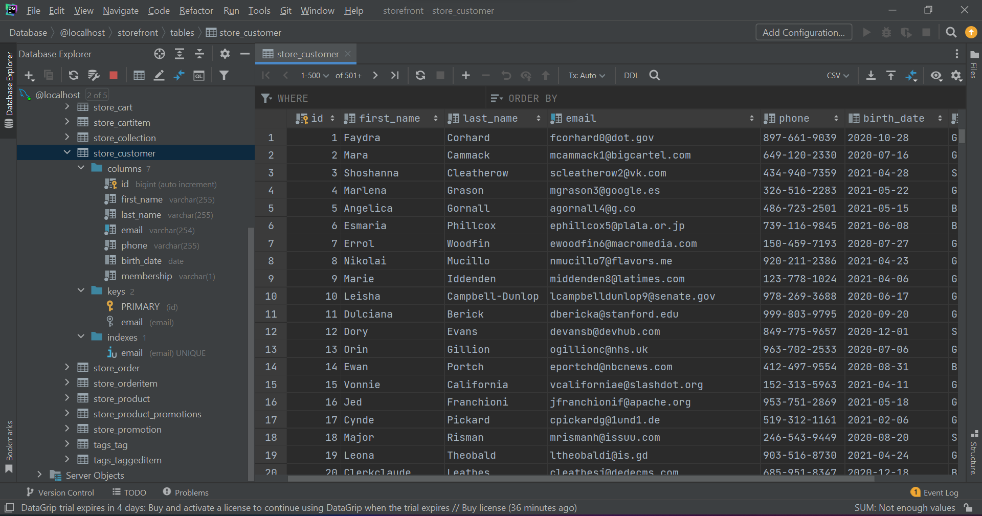

## BACKEND CODE:

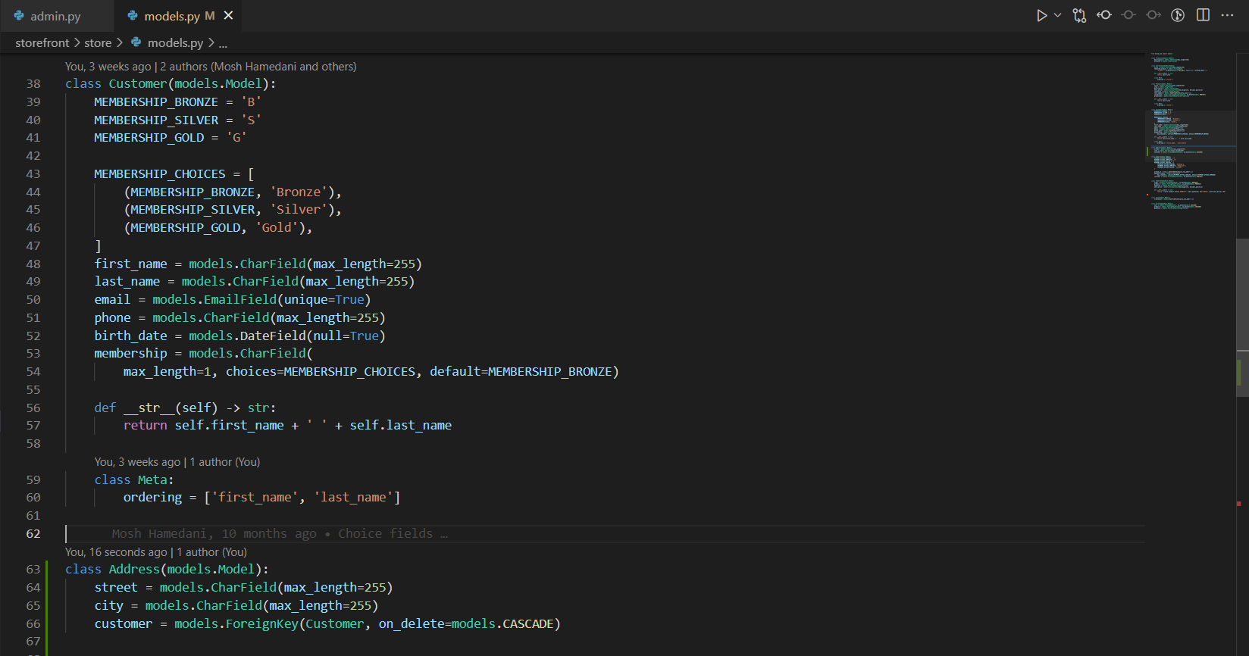

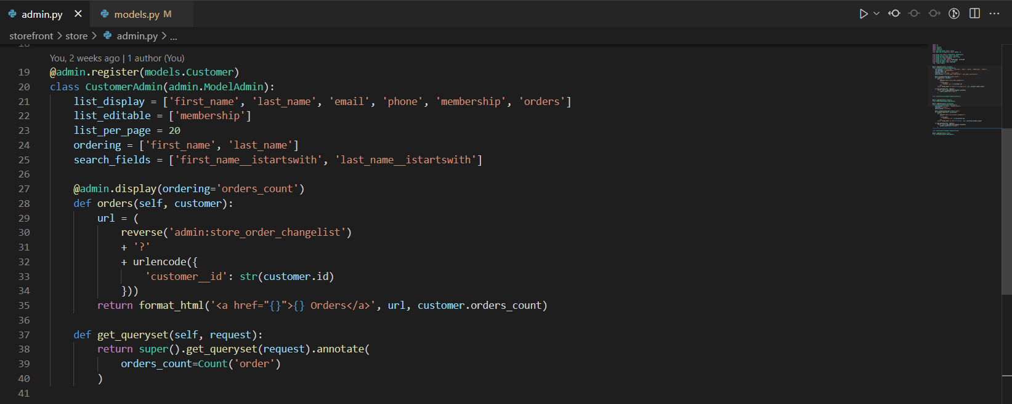

# ORDERS MODULE:

## SCREENSHOTS:

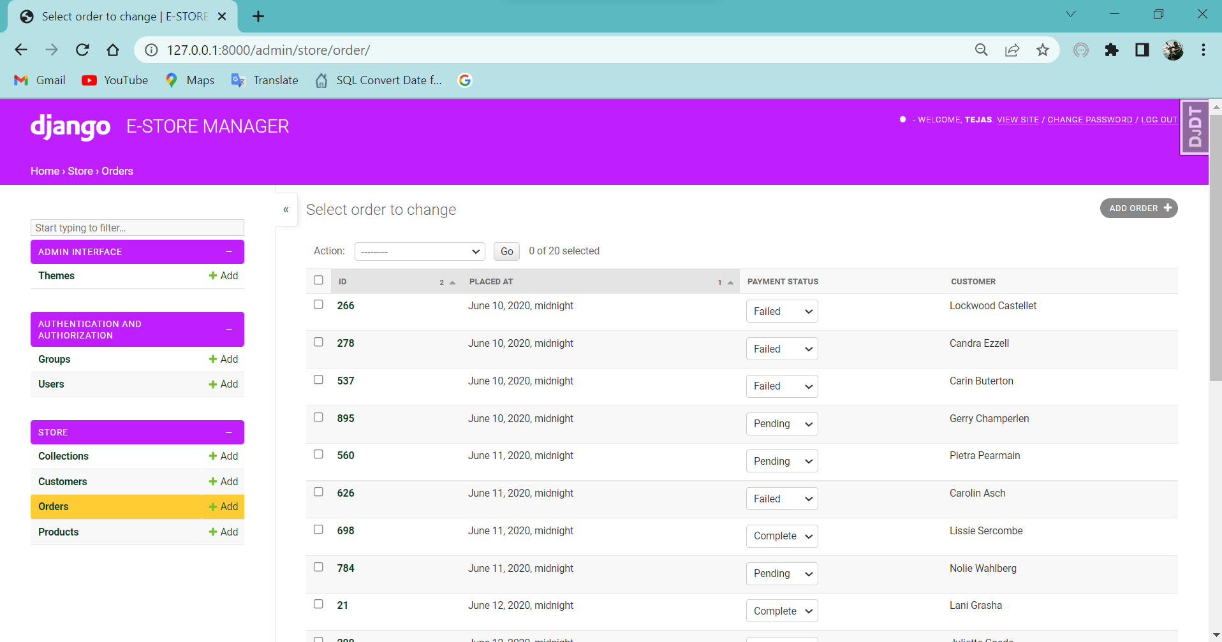

## DATABASE SCHEMAS:

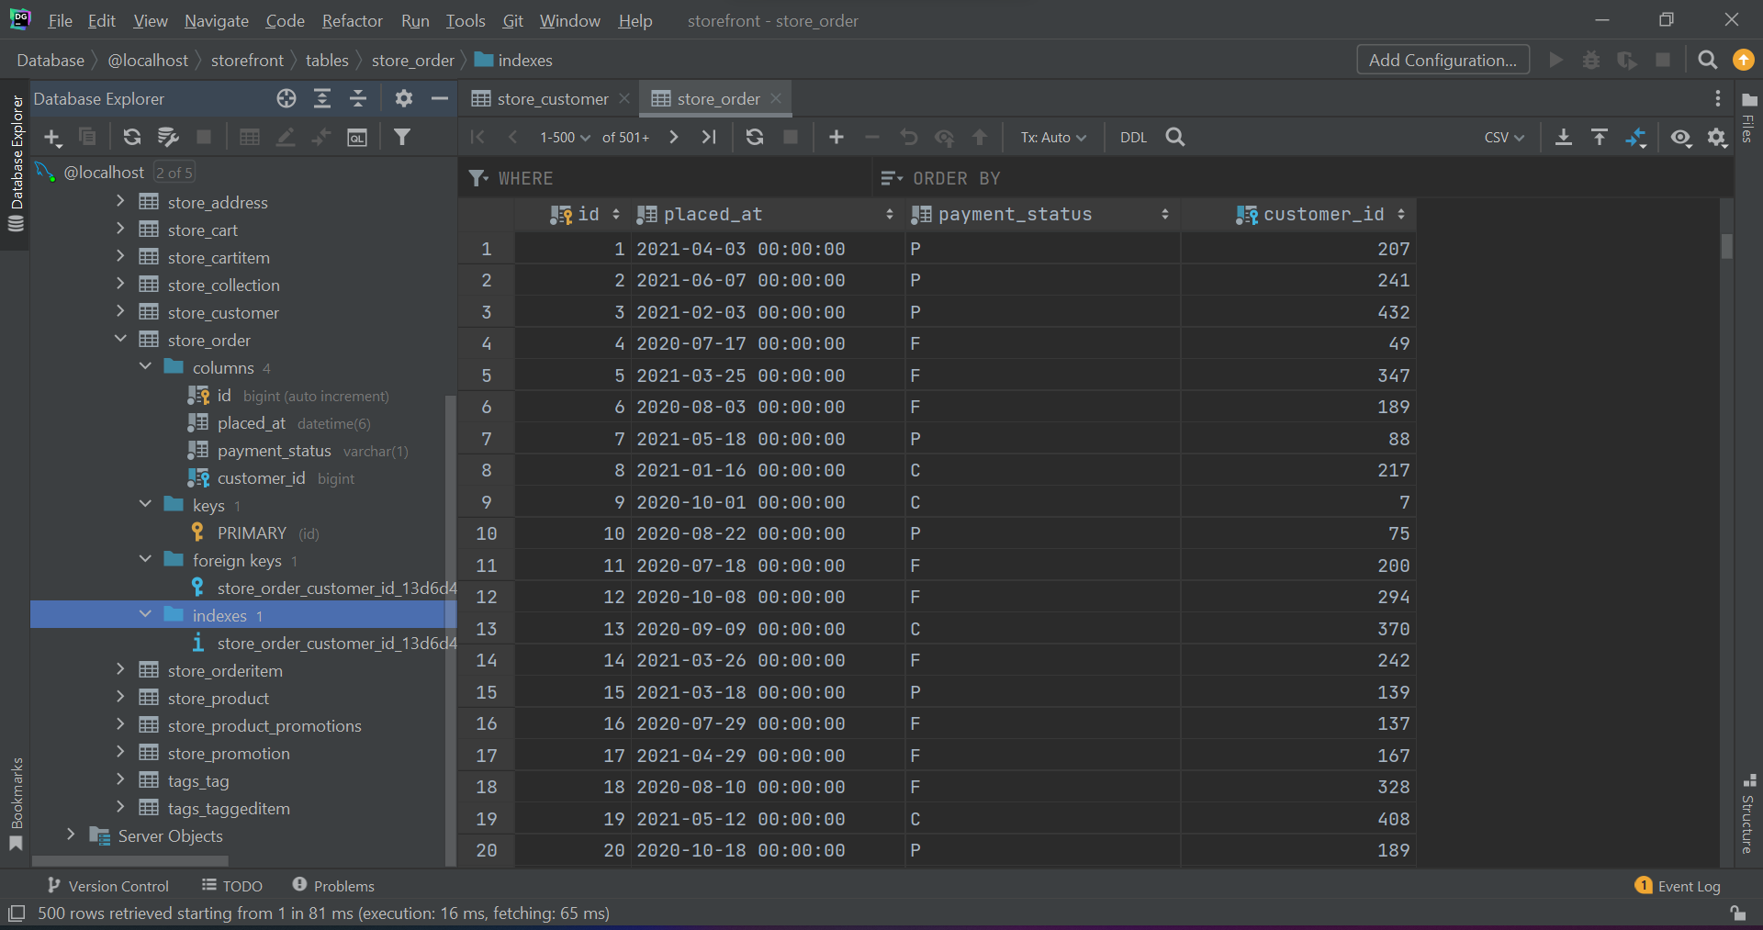

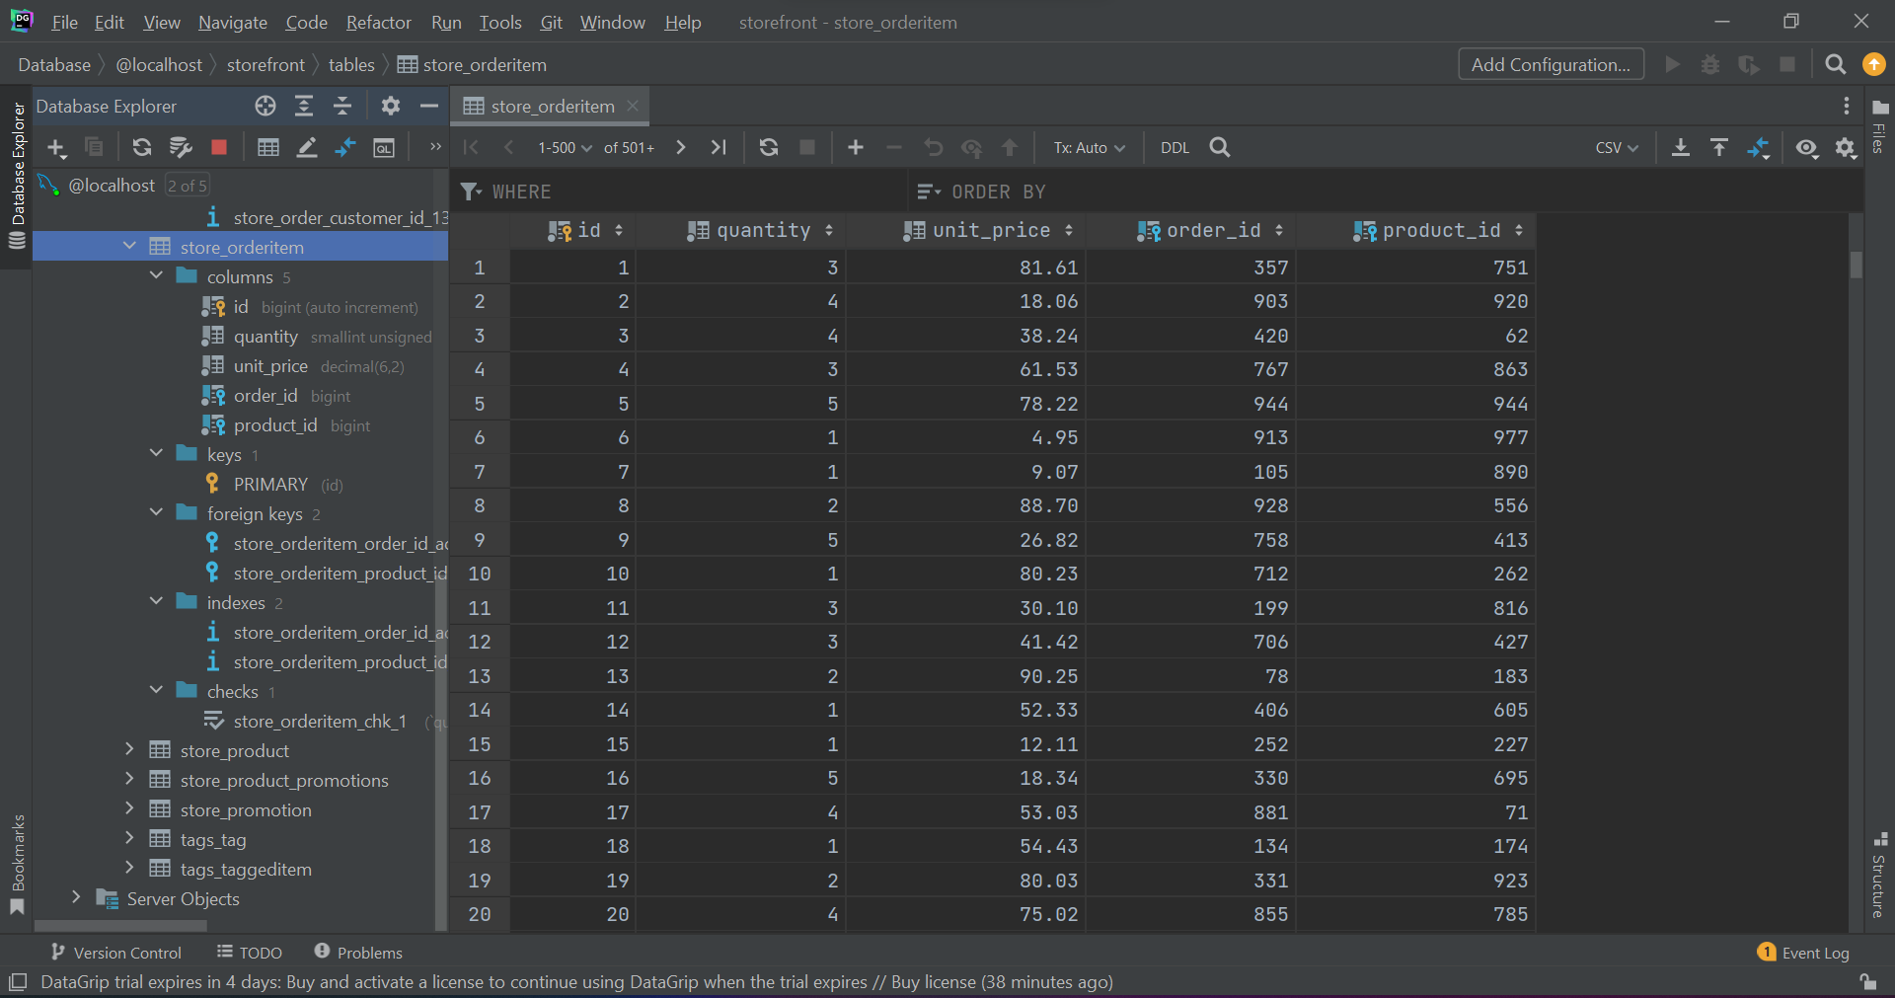

## BACKEND CODE:

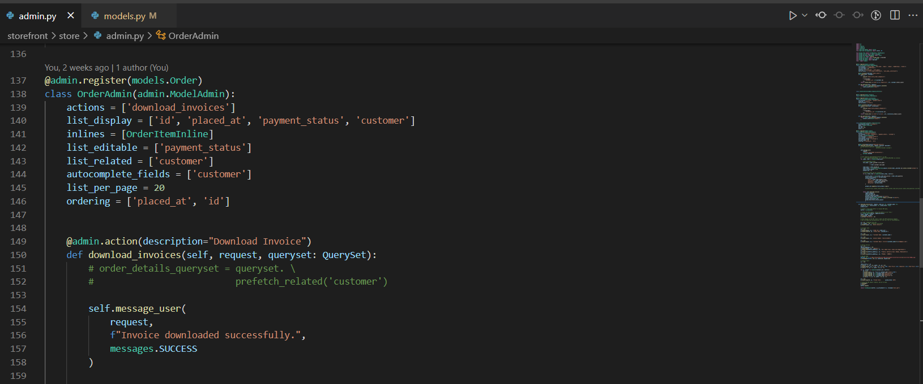

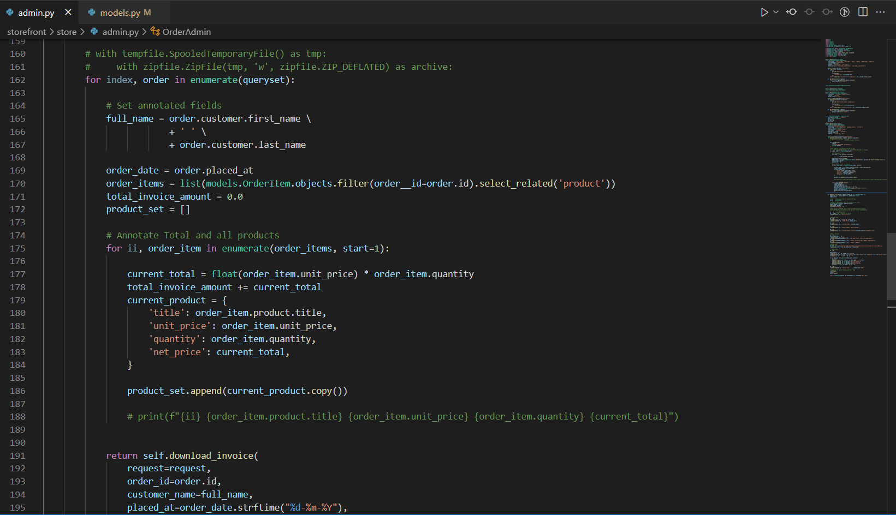

# PRODUCTS MODULE:

## SCREENSHOTS:

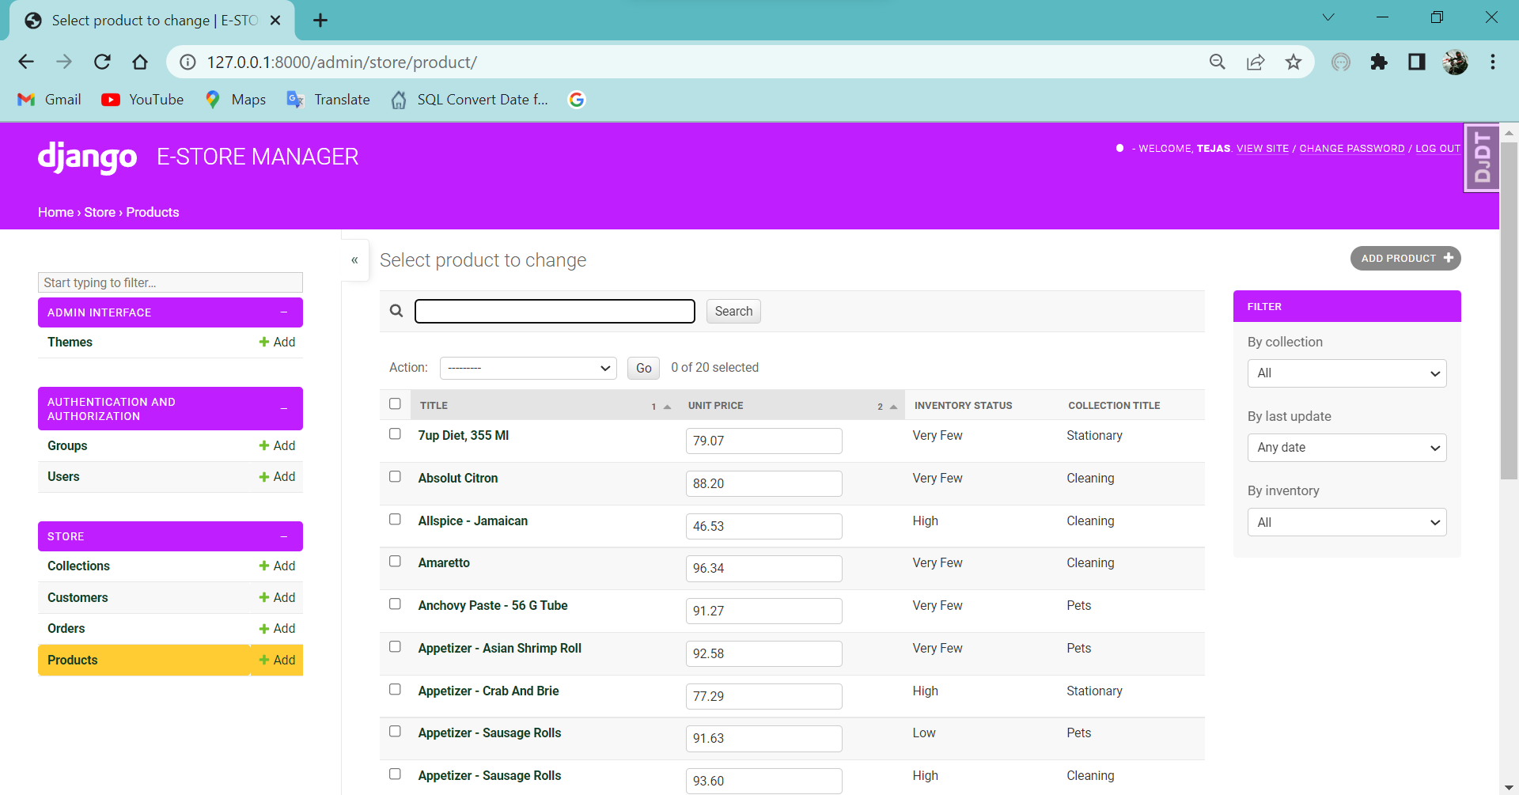

## DATABASE SCHEMAS:

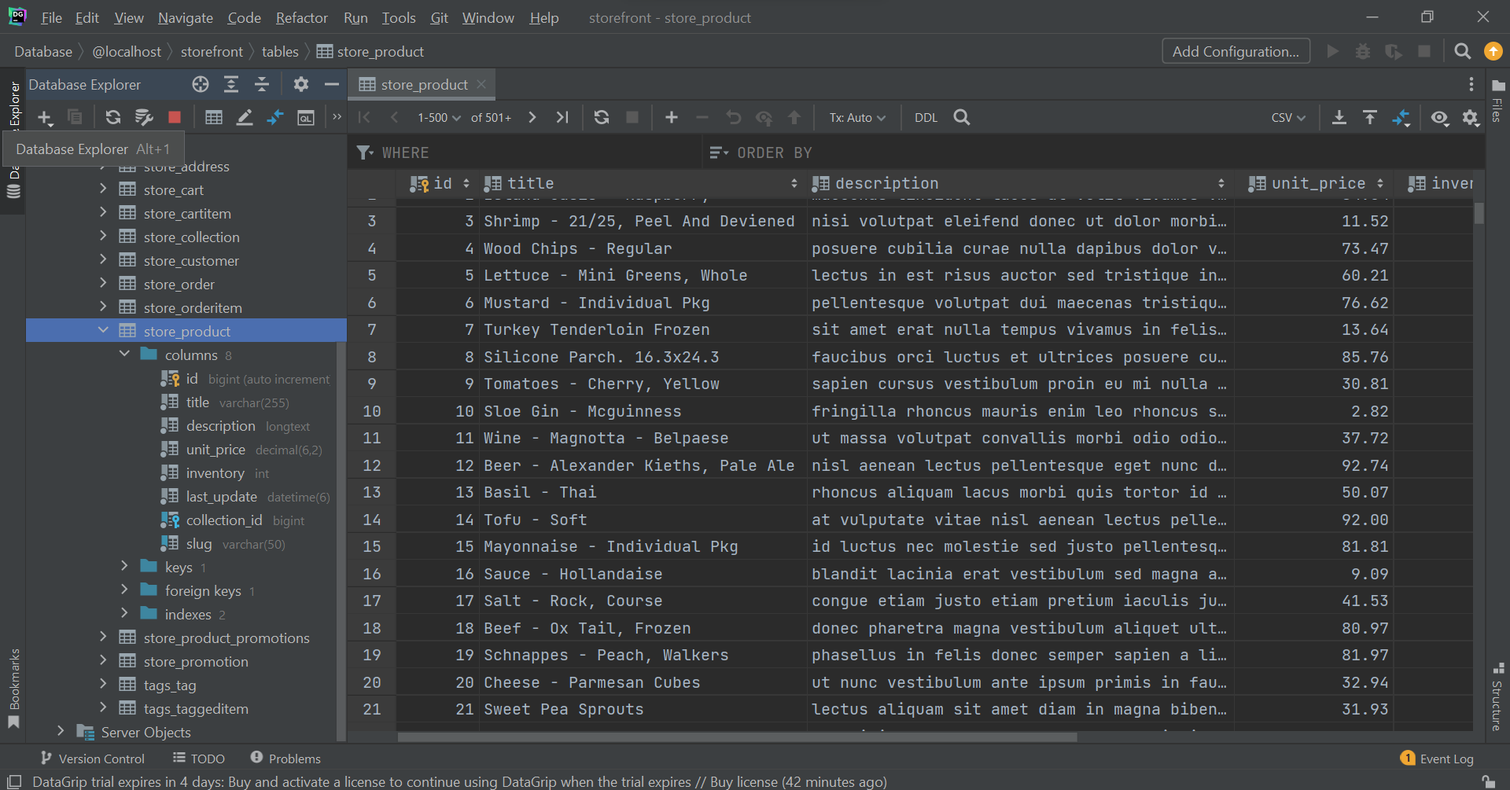

## BACKEND CODE:

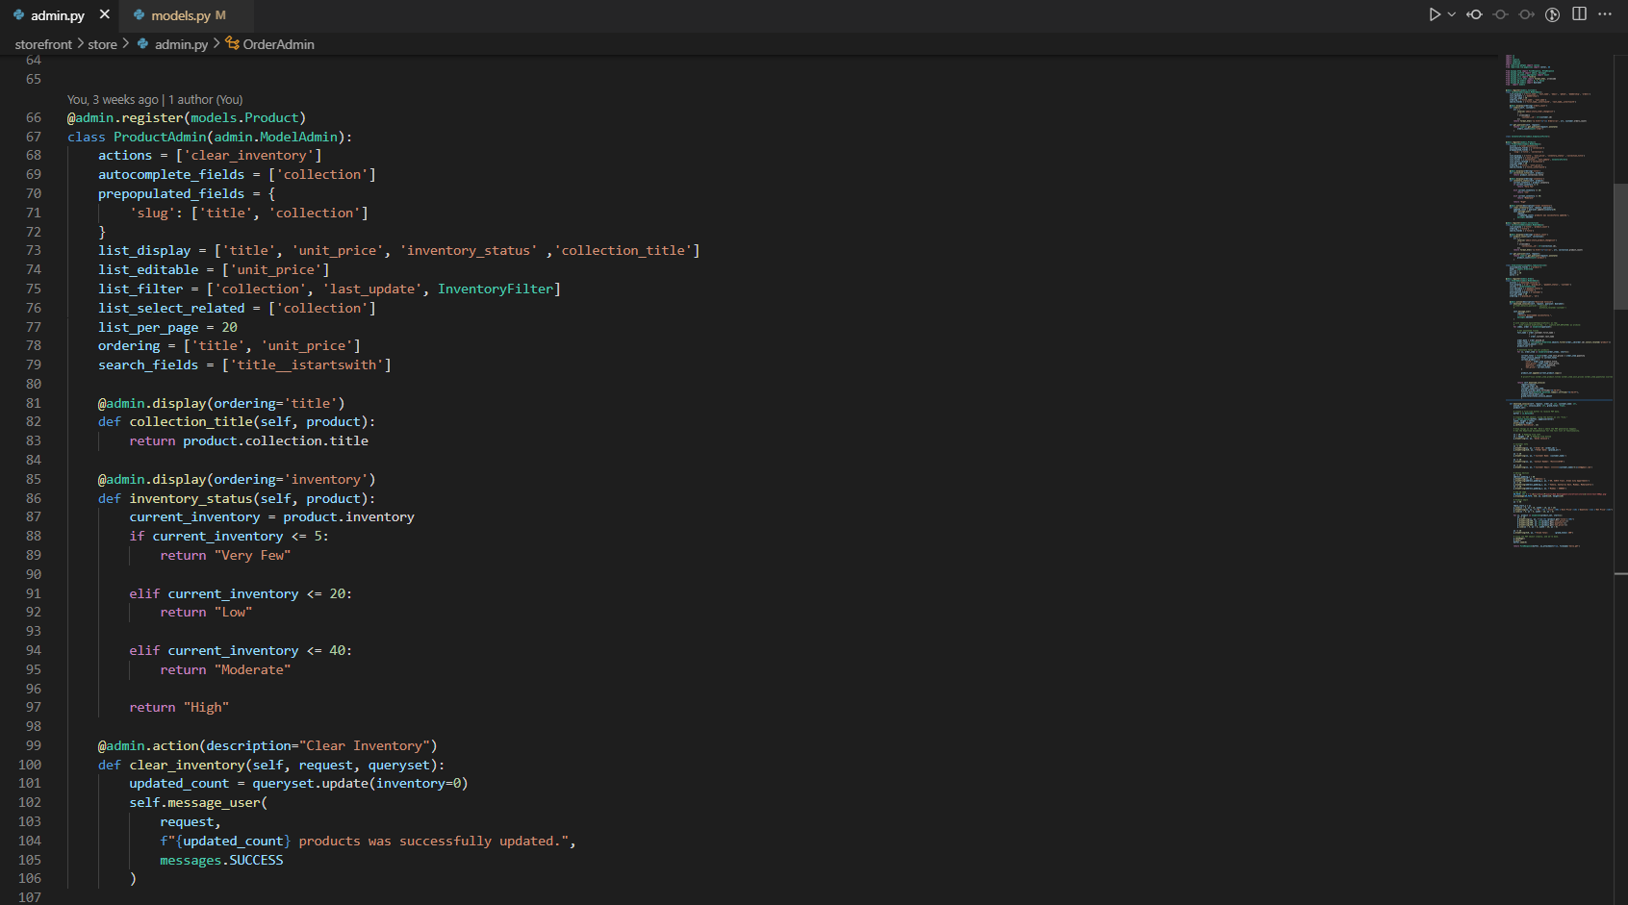

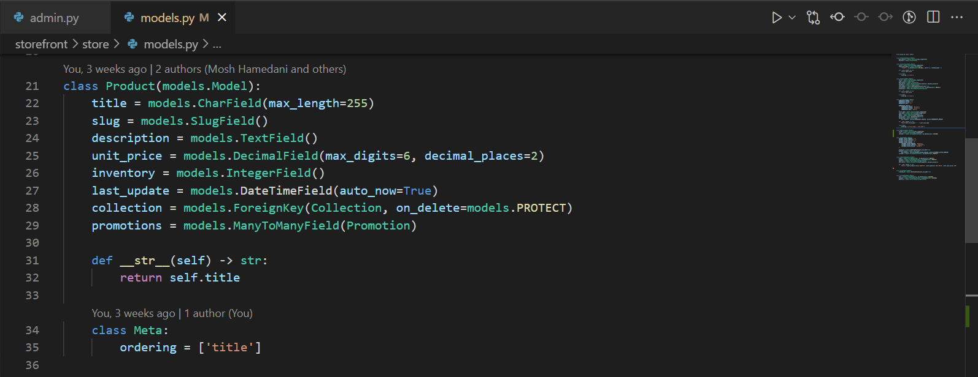

CHAPTER 6: Conclusion and futures

# Conclusion:

Most of the problems mentioned in the Chapter 1 and promises made are fulfilled, The limitations are still there but The project turned out to be much better and optimized than previously concluded.

The Database was changed from Postgres to MySQL and it worked really well. The schemas are precisely made and optimised as per user needs. The query data tools are very easy and faster.

The User Interface (UI) came out to be more customisable as well as ease of use experience.

We are able to add more users and assign roles to them accordingly. The set of permissions and access to certain databases can be modified by admin (super-user).

# PROJECT FUTURE:

The project has been finalized and ready to be deployed. For, Real-Life scenarios the project is compatible to work with REST API.

The E-Store Manager Application is future-proof to include the razerpay method to include UPI, Net Banking, Credit/Debit Card support.

The payment module can automate the online payment as well as manual payements.

The project is made in one of the largest Web Frameworks ‘Django’. Which has more room to grow and ease to add new features. The future for the project in Indian market is assured. This software needs low system requirements and is packed with many features that will boost the productivity of the local store employees as well as boost the profits and help in ‘Digital India’ Motto.

CHAPTER 7: BIbliography

# Credits and references:

## Sites:

### Python Docs 3.10

Link: <https://docs.python.org/3/>

### Django Documentation 4.0.0

Link: <https://docs.djangoproject.com/en/4.0/>

### Reportlab docs

Link: <https://www.blog.pythonlibrary.org/2010/03/08/a-simple-step-by-step-reportlab-tutorial/>

### CODEWITHMOSH ACADEMY

Link: <https://codewithmosh.com/>

## People:

### Tejas Kanji

Linked In: <https://www.linkedin.com/in/tejas-kanji/>

GitHub: <https://github.com/LordTejas>

**Thank You**